Family Support Worker – Social Care & Wellbeing

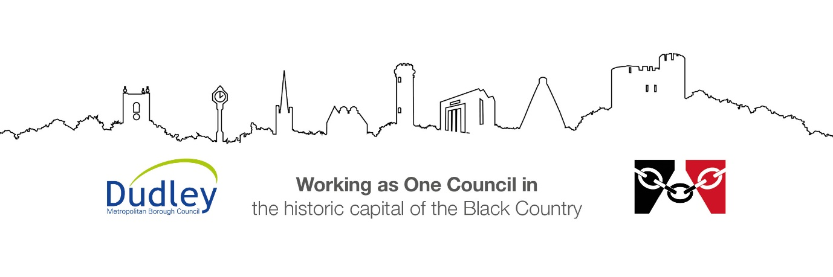

DMBC Operating Model 2024 - Vision:

A community-focused, financially resilient, collaborative, and sustainable council delivering the services required to support and meet the essential needs of residents, businesses, and the local economy.
Case for Change July 2024

Our Values:
Our values describe what we stand for and how we operate, and we expect our values to be lived and role-modelled throughout our organisation.

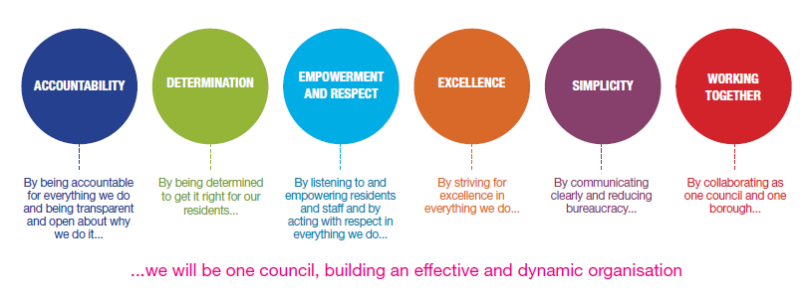
Job Description

Job Title: | Family Support Worker
Grade/Salary: | £28,508 -£31,022
Reports to: | Senior Practice Supervisor/Family Hub Manager
Post Number: | PS56

Role Purpose:
The primary purpose of the role is to work directly with targeted children, young people, families, parents and carers within the community by:
- Carrying out high quality Early Help Assessments, develop and implement high quality Early Help Family Plans.
- Working in partnership with families to ensure that they are provided with the right support at the right time to promote the welfare of children and young people living within the family.
- Reducing the risk of abuse and neglect and the need for statutory social care intervention.
- Proactively engage and support the most vulnerable and challenging children, young people and their families to strengthen the family and improve their outcomes, develop their resilience and reduce dependency upon specialist services.
- Delivering a ‘Think Family’ approach ensuring that all services working with the family are coordinated and work effectively together whilst maintaining a focus upon the safety and wellbeing of the children and young people.
- Implementing, monitoring and reviewing family support intervention plans, including the delivery of evidence based parenting programmes, activities and group work sessions to strengthen family resilience.
- Enabling the development of positive strategies to enable families to gain and maintain independence and control over all aspects of their lives and contribute positively within the community.
- Working assertively with families with complex often interrelated problems including reducing truancy and school exclusion, improving under attainment and aspiration through education, learning and employment, reducing antisocial behaviour and crime, improving health and developing a healthy lifestyle, maintaining and sustaining tenancies.
- Contributing to high quality assessments to secure the best outcomes for children and young people.
- Working alongside social workers to implement the Care plan when statutory intervention is required.
- Ensuring that all children, young people and vulnerable adults are adequately protected in line with Dudley Safeguarding Children and Adult Board reporting procedures.
- Working as an effective team member positively implementing the Early Help strategy, prioritising the needs of families in need of support and intervention.

Specific Responsibilities:

Specific Accountabilities | Expected Outcomes
Holds a family support caseload reflecting the function of the team in accordance with relevant policies, procedures and legislation. | - Cases are effectively managed and support plans implemented.  - Outcomes for children and young people are improved.
Undertakes and maintains an up-to-date Early Help Assessment, Early Help Family Plan and reviews for all allocated families. | - Early Help Assessments, Early Help Family Plans and reviews are evidence based, accurate, of a high standard and up-to-date.
Delivers protective or supportive intervention for children and young people with needs assessed at levels 3 and 4. | - Ensures that records are accurate and timely, in line with recording procedures  - Ensures that the allocated social worker is updated on the general progress of the family as appropriate.  - Works with families to maintain children in their families where it is safe to do so and delivers preventative interventions.  - Improves outcomes for children.
Early Help Family Plans are reviewed to determine progress against identified outcomes ensuring that the child’s welfare is paramount throughout. | - Demonstrates sound judgement regarding the needs of children and young people.  - Plans are implemented and reviewed to improve outcomes for the child.  - Analysis is effective in identifying risk and need.  - Whilst adopting a ‘Think Family’ approach it is important to retain a focus upon the safety and welfare of the children and young people in line with legislation and DSCB procedures.
Contributes to Community Based Assessments and PAMS assessments | - Assessments are well written, factual and balanced.
Ensures that records are up to date, of a high quality and submitted according to appropriate timescales. | - Records are accurate, up-to-date and produced within agreed timescales.  - Written English is of a high standard.
Writes good quality reports detailing the work undertaken with the family as required by Department, this includes Court Statements. | - Reports are of good quality, are factually accurate and balanced, are written to a good standard of English
Work co-operatively with colleagues and in partnership across agency boundaries. | - Effective partnership working is in place, producing high quality multi-agency plans to improve outcomes for children, young people and their families..
Attends a range of meetings including child protection case conference meetings, Step Down to Child in Need and Early Help Meetings. | - Provides factual balanced information to meetings in a professional manner
Leads Early Help meetings as appropriate | - Leads the Early Help meeting to enable family members and professionals to share information, accurately in a balanced and respectful manner.  - Facilitate the meeting to identify strengths and concerns.  - Enable the family to set achievable goals and goals for improvement with progress indicators and timescales.  - Review progress  - Record the notes from the meeting and construct the Early Help Family Plan.  - Arrange the review meeting ensuring that the date, time and location is agreeable to the family and takes account of family routines and pressures.
Engage with families in an assertive but supportive manner, enabling families to in identify the concerns / problems and the solutions. | - Family support service intervention is of high quality  - All family members fully participate in the decisions that affect them and develop Early Help Family Plans.  - Direct work undertaken with children and their families in accordance with agreed care plans to improve outcomes for children.  - The wishes and feelings of children and young people are ascertained, recorded accurately and taken account of in Early Help Family Plans and reviews.
Undertake planned and unplanned community based visits, including working within the families own home during weekdays, evenings, weekends and bank holidays on a rota basis to monitor and assess progress in engaging with, and achieving the agreed objectives within the ‘Plan’ | - Families are supported to sustain improvement outside of office hours  - Assessments capture information across the daily timetable of routines  - Families are strengthened, they develop resilience and strategies to meet children and young people’s needs and children and young people thrive  - Changes is levels of risk and vulnerability are identified early to enable protective safeguarding activity to be undertaken.
Carries out all work within equal opportunities and anti-discriminatory frameworks. | - Recognises and values diversity and is sensitive to cultural difference.  - Adheres to Dudley’s Values and Behaviours Framework.
Carries out statutory obligations in accordance with departmental policy and practice. | - Statutory obligations of the role are understood and complied with at all times.
Keeps up-to-date and act in accordance with current legislation and departmental practice and initiatives. | - Accurately interprets and applies relevant policies procedures and initiatives.  - Applies relevant policies to practice.
Develops/maintains good working relationships with other professionals in all agencies. | - Positive working relationships are fostered and maintained  - Effective partnership working and sharing of information.
Maintains accurate, up to date, and relevant case recordings and any other records as specified in departmental guidance and procedures’ and utilising tools such as the electronic Case Management system as appropriate. | - Accurate case records are in place in relation to own cases.  - Systems are utilised and maintained.  - Data is recorded timely and accurately.
Maintains regular supervision through frequent attendance at meetings and briefings in line with the Department’s supervision policy. Contribute to the development of other workers sharing knowledge and skills as appropriate. | - Receives and participates in supervision in accordance with agreed policy and practice.  - Shares knowledge and skills with colleagues as appropriate.  - Uses supervision to reflect and analyse cases and develop professional practice.
Reports changes to risk levels, care plans or children’s circumstances to their supervisor on a regular basis or immediately as required. Seeks advice on appropriate action, developing new risk assessments and care plans as guided by their supervisor | - Exercises effective judgement when assessing risk and seeks advice as appropriate to safeguard the welfare of children.  - Alerts line manager and allocated social worker (or EDT if out of hours) to emerging escalating risks and concerns regarding children and young people’s safety and welfare on the same working day.  - Children and young people are safeguarded.
Contributes through team meetings and organisational events to the development of the service. | - Makes a positive contribution to team meetings and events.
Maintains and develops up-to-date knowledge and relevant skills through continued learning. | - Undertakes learning and development opportunities as available, completing courses as advised by your supervisor.
Ensures that expenditure on cases is properly authorised and recorded, in accordance with departmental procedures. | - Expenditure is appropriately authorised and recorded.
Undertake planned and unplanned visits to families during weekdays, evenings and weekends on a rota basis to monitor and assess progress in engaging with, and achieving the agreed objectives within the ‘Plan’.  Family Support Service is provided on a rota basis evenings and weekends throughout the year | - Families receive effective support and intervention based upon assessed need  - The Outcomes for children and young people are improved and risk is reduced.  - Families are strengthened, they develop resilience and strategies to meet children and young people’s needs.  - Children and young people thrive.

Key Responsibilities:

- To be accountable for and promote equality, diversity and community cohesion to meet Group, Department and Function objectives. All employees have a responsibility not only for their own behaviour, but also for others regarding equality of opportunity. Any incident must be reported.

- To participate in a Performance Review and Development meeting and undertake a plan of training where necessary. Develop his/her own skills and expertise in a professional manner.

- In addition to all the responsibilities listed above, all employees must be flexible in their approach and undertake other duties that are commensurate with post holder’s level, wherever they may be, to achieve the objectives of the Group.

- To represent the Council and Group in a professional manner meeting the Corporate and Group aims. To comply with Group and Corporate policies.

- If appropriate to be responsible for the recruitment and performance management of designated teams and individuals in accordance with Corporate and Group aims and management style.

- To comply with the council’s financial regulation and standing orders

- To actively promote Dudley’s commitment to safeguarding and promoting the welfare of children, young people and vulnerable adults at a level appropriate to this group.

- Employees must comply with health and safety legislation and will be required to comply with the Council’s Health and Safety Policies. All employees must ensure that they take reasonable care of their own health and safety as well as the health and safety of any person that is affected by their actions.

- To be responsible for adhering to legislative requirements and Council Policies and Procedures including, but not exclusively health & safety, Data Protection and Internet/Email use.

Special Conditions:

This post is subject to the DBS checking process (delete if not applicable)

Driving Licence will be subject to checking with the DVLA. It is a council requirement to have Business Use Car Insurance and a valid MOT certificate (For cars over 3 years old) (delete if not applicable)

The post holder is required to work onsite 3 days per week

Prepared by: | Shirley Shea
Date: | 06/07/2026

Essential criteria:
Person Specification
Qualifications and Experience |  | Application form | Technical assessment | Interview
 | Professional qualification relevant to work with children and families at NVQ3 or above or;  Working towards professional qualification relevant to work with children and families at NVQ3 | √ |  | √
 | Good Literacy and English writing and numeracy skills level 3 and above | √ | √
 | Evidence of continued learning and development | √
 | Good level of IT skills and application | √
 | Experience of working with children, young people and families at risk of statutory intervention. | √ |  | √
 | Experience of working with families with multiple and complex interrelated problems. | √ | √ | √
 | Experience of working with families with multiple and complex interrelated problems. | √ |  | √
 | Experience of carrying out risk and needs assessment and the development, coordination, implementation, monitoring and review of Early Help Family Plans | √ | √ | √
 | Experience of working in a multi-agency setting/environment. | √ |  | √
Skills and abilities
 | Proven commitment to public service and the ability to champion equality, diversity and inclusion and embedding these as core values | √ |  | √
 | Good ability to work in partnership with children and families and a wide range of agencies. | √ |  | √
 | Good ability to keep accurate and up to date records. | √ |  | √
 | Good ability to effectively engage and sustain relationships with children, young people and their families |  |  | √
 | Good ability to communicate effectively orally and in writing, and to produce a variety of information to aid decision making | √ |  | √
 | Good ability to work effectively and as part of a team |  |  | √
 | Good knowledge of child development and the needs of children and young people |  | √ | √
 | Proven ability to lead and co-ordinate child centred meetings |  |  | √
 | High standard of recording skills |  | √
 | Ability to undertake assessments and devise effective Early Help Family Plans |  | √ | √

