Apprentice Customer Service – Homeless Prevention Response Team



DMBC Operating Model 2024 - Vision:

A community-focused, financially resilient, collaborative, and sustainable council delivering the services required to support and meet the essential needs of residents, businesses, and the local economy.
Case for Change July 2024

Our Values:
Our values describe what we stand for and how we operate, and we expect our values to be lived and role-modelled throughout our organisation.

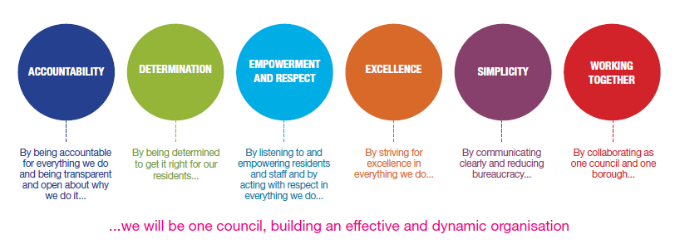
Job Description

Job Title: | Apprentice Customer Service
Grade and Salary: | National minimum wage for age
Reports to: | Team Leader
Post Number:

Role Purpose:
To assist Housing Advice Assistants (HAAs) who are the front face of the service, dealing with all customer and partner agency enquiries

Specific Responsibilities:
- Dealing with telephone enquiries, with appropriate discretion, taking messages
- Contacting relevant directorates and passing on information
- Using appropriate IT software packages to access and produce information.
- To provide a comprehensive administrative support service
- To provide a high-quality customer care service to staff, service users, visitors and others who come into contact with the service
- Provide the teams administration and are responsible for all back-office functions; letter writing, post, updating case management systems, maintaining accurate records
- Giving basic homelessness/housing advice or referring to HPRT staff, other agencies, and departments within the housing service as appropriate
- To assist Housing Advice Assistants (HAAs) are the front face of the service, dealing with all customer and partner agency enquiries
- Good inter-personal skills and ability to work constructively within a large team.
- Responsible for maintaining records of all homelessness approaches.
- Respond positively/constructively during periods of heavy workload or situations requiring a flexible approach.
- Input and interrogate data
- Responsible for case administration; letters, updates, appointments scheduling etc
- Understanding of the importance of performance monitoring and data management.
- Collect, record and present information as directed for performance indicators and government statistics.

Key Responsibilities:

- To be accountable for and promote equality, diversity and community cohesion to meet Group, Department and Function objectives. All employees have a responsibility not only for their own behaviour, but also for others regarding equality of opportunity. Any incident must be reported.

- To participate in a Performance Review and Development meeting and undertake a plan of training where necessary. Develop his/her own skills and expertise in a professional manner.

- In addition to all the responsibilities listed above, all employees must be flexible in their approach and undertake other duties that are commensurate with post holder’s level, wherever they may be, to achieve the objectives of the Group.

- To represent the Council and Group in a professional manner meeting the Corporate and Group aims. To comply with Group and Corporate policies.

- If appropriate to be responsible for the recruitment and performance management of designated teams and individuals in accordance with Corporate and Group aims and management style.

- To comply with the council’s financial regulation and standing orders

- To actively promote Dudley’s commitment to safeguarding and promoting the welfare of children, young people and vulnerable adults at a level appropriate to this group.

- Employees must comply with health and safety legislation and will be required to comply with the Council’s Health and Safety Policies. All employees must ensure that they take reasonable care of their own health and safety as well as the health and safety of any person that is affected by their actions.

- To be responsible for adhering to legislative requirements and Council Policies and Procedures including, but not exclusively health & safety, Data Protection and Internet/Email use.

Special Conditions:

This post is subject to the DBS checking process

The post holder is required to work onsite 5 days per week

Prepared by: | Paula Pallant
Date: | Aug 26

Essential criteria:
Person Specification
Qualifications and Experience |  | Application form | Technical assessment | Interview
 | Understanding of and a passion for delivering customer service | x |  | x
 | Willingness to undertake a Level 2 Apprenticeship in Customer Service | x
 | Willingness to work towards Level 2 Functional Skills in Math’s and English (Not applicable if you already hold a GCSE at Level 4 and above) | x
 | Willingness to engage in corporate training and service training as appropriate | x
Skills and abilities
 | Proven commitment to public service and the ability to champion equality, diversity and inclusion and embedding these as core values | x |  | x
 | Ability to communicate effectively via the telephone, face-to-face and in writing | x |  | x
 | Be supportive of team members and work effectively as part of a team. | x
 | Computer skills, including a working knowledge of MS Office products (especially Word and Outlook). | x |  | x
 | An appreciation of the need for high standards of customer care at all times – including politeness, courtesy, respect and understanding | x |  | x
 | Excellent time keeping and attendance and flexibility with regard to working hours. | x |  | x
 | Demonstrate empathy and sensitivity towards customers, ensuring every customer has equal access to services by understanding the diverse cultures and needs. |  |  | x
 | Committed to seeing tasks completed and achieving a high quality service | x |  | x
 | Desire to continually improve and develop skills and knowledge |  |  | x
 | Prepared to ensure customers are the priority under the guidance of experienced staff and management. | x |  | x

