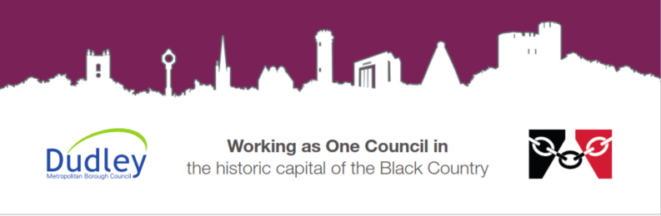
Lead Education Advisor for children with a social worker


DMBC Operating Model 2024 - Vision:
A community-focused, financially resilient, collaborative, and sustainable council delivering the services required to support and meet the essential needs of residents, businesses, and the local economy.
Case for Change July 2024

Our values:
Our values describe what we stand for and how we operate, and we expect our values to be lived and role-modelled throughout our organisation.
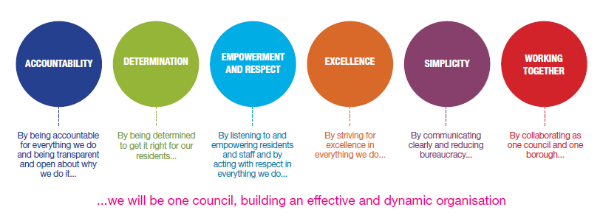
(to be updated 2025)

Our vision

Job title: | Lead Education Advisor for Children with a social worker
Grade/Salary: | 11
Reports to: | Virtual School Head Teacher
Post number:

Overview
The Lead Education Advisor plays a key role within the Virtual School team, leading on the development and delivery of educational priorities that aim to improve outcomes for children and young people who have or have had a social worker. Working under the direction of the Virtual School Headteacher, the postholder provides leadership, challenge and support to schools, settings, and partner agencies to raise aspirations and drive improved educational achievement.
The role is responsible for ensuring that children in care, previously looked after children, children in kinship care, and those with a social worker have access to high-quality, stable and inclusive education. This includes working collaboratively with education providers, social care and other agencies to remove barriers to learning, promote engagement, and support sustained progress and attainment.

Through oversight, the Lead Education Advisor monitors educational performance, uses data to identify trends and priorities, and coordinates targeted interventions for those most at risk of poor outcomes. The postholder also plays a central role in strengthening partnership working, influencing multi-agency planning, and ensuring that education is a key focus within wider support for children and families.

Role purpose:
- To lead and develop the children with a social worker function within the Virtual School team, taking responsibility for key educational priorities that promote, champion and improve outcomes for all children and young people who have or have ever had a social worker.

- Working under the leadership and direction of the Virtual School Headteacher, the postholder will provide robust challenge, scrutiny and support to partners, settings and professionals to raise aspirations and secure improved educational achievement for children in care, previously looked after children, children in kinship care, and children with a social worker.

- The role will work collaboratively with schools, local authority services and partner agencies to ensure education is consistently prioritised for these groups, removing barriers to learning and promoting stability and inclusion.

- A core responsibility is to ensure that children in care, previously looked after children and children with a social worker are maintained in, or re-engaged with, suitable, high-quality educational provision, supporting sustained engagement, progress and attainment.

Key responsibilities:
- Lead on the delivery of educational priorities set out in the Virtual School Business Plan, ensuring alignment with corporate parenting responsibilities and the Families First programme focus on early intervention and prevention.

- Provide oversight of educational outcomes for Children in Care (CiC), Previously Looked After Children (PCLA), and Children with a Social Worker (CWSW) and those in Kinship care ensuring a whole-child and whole-family approach.

- Lead the implementation and review of relevant service policies, ensuring practice reflects statutory guidance and integrated working across services.

- Champion multi-agency working in line with the Families First programme by building strong partnerships with education, social care, health and community services.

- Promote education as a protective factor by working collaboratively with partner agencies to raise aspirations and achievement for CiC, PCLA and CWSW.

- Contribute to and influence multi-agency planning, ensuring education is central to assessments, plans, and interventions that support families holistically.

- Work proactively with families, carers and professionals to strengthen relationships and remove barriers to engagement in education.

- Identify, prioritise and coordinate targeted support for children and young people most at risk of poor educational outcomes.

- Support high-quality inclusive practice across mainstream and specialist educational settings to improve outcomes and stability.

- Ensure timely and effective intervention for those experiencing vulnerability, disruption or key transition points.

- Monitor, evaluate and report on the attainment, progress, attendance, and engagement of allocated cohorts.

- Work with identified schools and settings to track and improve attendance and outcomes for Children with a Social Worker.

- Use data and insight to inform practice, identify trends and support service improvement and targeted intervention.

- Take a strategic lead in coordinating support for key educational transitions (Early Years to Post-16 and beyond), ensuring continuity and progression.

- Maintain consistent support and contact during critical transition periods, including entry into care, placement changes, school moves and post-16 pathways.

- Manage a defined caseload providing advice, challenge and support to designated teachers and settings.

- Ensure all case records are accurate, up to date, and compliant with data protection and information-sharing protocols.

- Promote, quality assure and support the completion of high-quality and timely Personal Education Plans (PEPs).

- Develop and maintain effective working relationships with designated teachers, DSLs, school leaders and education providers.

- Provide constructive challenge and support to schools to secure improved outcomes, attendance and inclusion.

- Undertake regular liaison and visits to allocated schools to review progress and strengthen partnership working.

- Prepare high-quality reports, briefings and presentations for internal and external stakeholders, evidencing impact and outcomes.

- Contribute to service evaluation, audit and review processes, supporting continuous improvement.

- Ensure strict confidentiality and adherence to data-sharing agreements in line with statutory and local requirements.

- Maintain robust recording practices across all systems and processes.

Special conditions:
This post is politically restricted.
This post may be subject to the DBS checking process.
Driving Licence will be subject to checking with the DVLA. It is a council requirement to have business use car insurance and a valid MOT certificate (For cars over 3 years old).

Prepared by: Emma Thomas

Date: 18th June 2026

Person specification - Essential criteria:

Qualifications and experience
Demonstrable strong record of improving educational outcomes for Children in Care, Previously Looked After Children and children with a Social Worker, alongside a clear commitment to and experience in safeguarding practice within an educational setting.

Substantial experience of working within education, children’s services or a related field, with a strong focus on vulnerable children and young people and a proven track record of promoting and embedding effective safeguarding practice.

Experience of working effectively in a multi-agency environment, including collaboration with schools, social care, health and other partners.

Proven experience of analysing and using data to identify need, monitor performance and drive improvement.

Experience of providing constructive challenge and support to schools or professionals to improve attendance, attainment and inclusion.

Experience of working directly with families and carers to support engagement in education.

Degree-level qualification or equivalent relevant professional qualification. For example; teaching qualification (e.g. QTS) or equivalent, or significant relevant professional experience (desirable).

Evidence of continued professional development relevant to education, safeguarding, inclusion or leadership.

Training in safeguarding and child protection (e.g. DSL trained).

Relevant leadership/management qualification (desirable).

Skills and abilities
Excellent communication skills (written and verbal), including the ability to produce high-quality reports, present information clearly and influence stakeholders.

Ability to build effective professional relationships and partnerships across agencies and sectors.

Skilled in challenging appropriately and constructively to drive improvement.

Strong organisational and time management skills, with the ability to manage competing priorities and a varied caseload.

Competent in the use of IT systems, including data management and reporting tools.

Strong commitment to equality, diversity and inclusion.

Resilient, adaptable and solution-focused, with the ability to respond positively to challenge and change.

Collaborative and approachable, with a commitment to partnership working.

Confident and credible approach, with the ability to influence and negotiate effectively at all levels.

An ability to fulfil all spoken aspects of the role with confidence using the English Language as required by Part 7 of the Immigration Act 2016.


