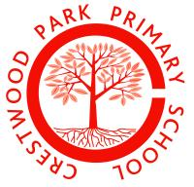

Cleaner
Permanent 11.25 hours per week

Crestwood Park Primary School
Lapwood Avenue,
Kingswinford,
DY6 8RP

We require a well-motivated, hardworking and positive member of our cleaning team. Starting as soon as possible.

We are a welcoming and friendly school who have high expectations for ourselves and our children.

This permanent role is 11.25 hours per week and will be subject to a 6 month probationary period.
Afternoons for 2.25 hours per day.
Specific start /finish times to be discussed at interview.

We welcome visits to school if you wish to have a look around.

Applications close on Tuesday 15th October.
Shortlisting on Wednesday 16th October.
Interviews on Friday 18th October (times tbc)

For further details, please read the person specification and job description.

To book a visit or for any further enquiries, please contact Mrs Hughes in the school office 01384 818315.

Our statement of Commitment
Crestwood Park Primary School is committed to safeguarding and promoting the welfare of children and young people and expects all staff and volunteers to share this commitment. All shortlisted candidates will be subject to an online check. All posts are subject to Enhanced DBS Clearance, TRA Teacher Services, Qualification and ID Checks.

