Principal Health & Safety Officer

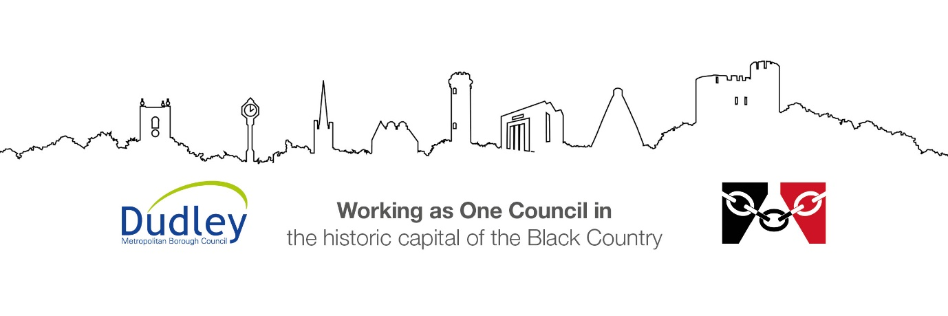

DMBC Operating Model 2024 - Vision:

A community-focused, financially resilient, collaborative, and sustainable council delivering the services required to support and meet the essential needs of residents, businesses, and the local economy.
Case for Change July 2024

Our Values:
Our values describe what we stand for and how we operate, and we expect our values to be lived and role-modelled throughout our organisation.

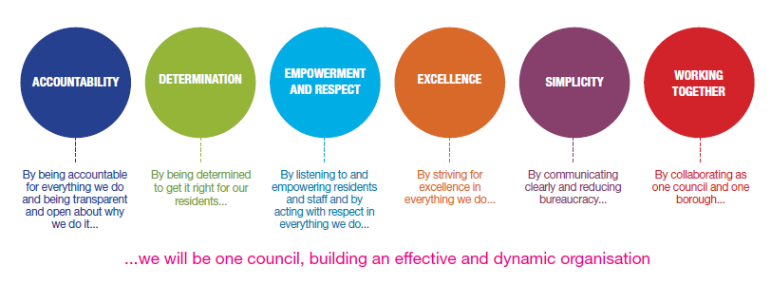
Job Description

Job Title: | Principal Health & Safety Officer
Grade and Salary: | 11 (SCP 36-39), £47,181 - £ 50,269
Reports to: | Corporate Health & Safety Manager
Post Number: | P152200

Role Purpose:
- Provide competent and professional occupational health & safety advice and guidance to the Chief Executive, Directors, Head Teachers/Principals, Assistant Directors, other managers and employees.
- Assist and inspire senior managers in the development and promotion of a positive health & safety culture.
- Keep up to date with new and emerging legislation and develop plans to implement across the Council and the school estate as directed by the Corporate Health & Safety Manager (CHSM).
- Assist the CHSM with the planning, promotion, implementation and assessment of health & safety policies and procedures.
- At the request of the CHSM, to lead on the development of effective corporate policies, procedures, guidance and management systems (accident reporting system, performance management) that meets the needs of the Council and comply with legislative requirements.
- At the request of the CHSM, to lead on the development and successful delivery of corporate health & safety training strategies and packages in line with legislative requirements and the Council’s needs.
- To deputise for the CHSM when required in:
  - Acting as the Council’s advisor on all matters relating to health and safety legislation and its effect on the Council’s business needs.
  - Engaging with stakeholders at Corpporate Management Team (CMT) and senior management level on the development of the Council’s strategic vision and direction for health and safety.
  - Attending the Corporate Health and Safety Steering Group, advising on new and emerging health and safety legislation and giving advice on the actions the Council should implement in response.
- Audit and monitor the effectiveness of implementation of corporate policies and procedures across the Council.
- Respond to serious health & safety incidents in a timely and competent manner, providing written and verbal reports to the CHSM and senior management.
- To represent the Council and its interests in engagements with the Health & Safety Executive, Fire Service and other relevant enforcement agencies.
- To represent the Council in the event of investigations into our practices by relevant enforcement agencies.
- To consult with and influence internal and external stakeholders to successfully implement corporate health & safety policies.

Specific Responsibilities:

- Provide competent professional advice and direction to senior management across the Council and support corporate health & safety colleagues as the need arises.
- Develop effective corporate policies, procedures, guidance and management systems (accident reporting system, performance management) that meet the needs of the Council, including the school estate, to comply with legislative requirements.
- Provide senior managers with a clear interpretation of their legal responsibilities to enable effective planning and decision-making.
- Monitor and audit/review processes and working arrangements to ensure legal and corporate compliance.
- Formulate and provide training across the Council.
- Identify the causes of poor performance within safety management systems and bring to the attention of the CHSM.
- At the request of the CHSM, act as the Council’s representative at national and local health and safety forums and seminars which have an impact on the council’s business activities (e.g., Fire Authorities, IOSH, West Midlands Regional Health & Safety Group, West Midlands Regional Education Health & Safety Group)
- To deputise for the CHSM and advise CMT of significant health and safety issues which need to be brought to their attention
- To deputise for the CHSM where required and advise the Corporate Health and Safety Management Group (chaired by the Chief Executive or nominated deputy) on health and safety issues of a significant nature, such a new legislation or HSE initiatives, that may inpact on the Council’s operations and need positive action
- Liaise with enforcement agencies/government bodies where required.
- Ensure that health & safety arrangements of all suppliers to the Council are assessed in accordance with Standing Orders.
- Assist in monitoring and reviewing the Council’s Emergency Plans with respect to serious and imminent danger.
- Assist in the development and prioritisation of the health & safety work programme.
- Where required, liaise with other local authorities on common health & safety issues affecting the work of local authorities.
- At the request of the CHSM and as the need arises, act as the Council’s representative at national and regional health & safety forums and seminars which have an impact on the Council’s business activities.
- Assist in the production of health & safety reports and analysis to advise Senior Executive Board of the Council’s health & safety performance.
- Where required, deputise for the CHSM and advise the Corporate Health & Safety Management Group on specific health & safety issues of a significant nature, such as new legislation or HSE initiatives, that may impact on the Council’s operations and need positive action.
- Advise Managers on their health surveillance obligations within the regulatory requirements of health & safety legislation.
- Assist the CHSM in monitoring the effectiveness of the Council’s health & safety information systems, ensuring they remain up-to-date and available to Council employees.
- Assist or, in the absence of the CHSM, take the lead in investigating major accidents, fatalities and dangerous occurrences.
- Advise managers, schools management and responsible persons on emergency arrangements required.
- Carry out such associated health & safety duties which may arise, develop or be assigned by the CHSM.

Key Responsibilities:

- To be accountable for and promote equality, diversity and community cohesion to meet Group, Department and Function objectives. All employees have a responsibility not only for their own behaviour, but also for others regarding equality of opportunity. Any incident must be reported.

- To participate in a Performance Review and Development meeting and undertake a plan of training where necessary. Develop his/her own skills and expertise in a professional manner.

- In addition to all the responsibilities listed above, all employees must be flexible in their approach and undertake other duties that are commensurate with post holder’s level, wherever they may be, to achieve the objectives of the Group.

- To represent the Council and Group in a professional manner meeting the Corporate and Group aims. To comply with Group and Corporate policies.

- If appropriate to be responsible for the recruitment and performance management of designated teams and individuals in accordance with Corporate and Group aims and management style.

- To comply with the council’s financial regulation and standing orders

- To actively promote Dudley’s commitment to safeguarding and promoting the welfare of children, young people and vulnerable adults at a level appropriate to this group.

- Employees must comply with health and safety legislation and will be required to comply with the Council’s Health and Safety Policies. All employees must ensure that they take reasonable care of their own health and safety as well as the health and safety of any person that is affected by their actions.

- To be responsible for adhering to legislative requirements and Council Policies and Procedures including, but not exclusively health & safety, Data Protection and Internet/Email use.

Special Conditions:

This post is subject to the DBS checking process (delete if not applicable)

Driving Licence will be subject to checking with the DVLA. It is a council requirement to have Business Use Car Insurance and a valid MOT certificate (For cars over 3 years old) (delete if not applicable)

The post holder is required to work onsite 3 days per week

Prepared by: | Adam Hammerton
Date: | 23/07/26

Essential criteria:
Person Specification
Qualifications and Experience |  | Application form | Technical assessment | Interview
 | Extensive experience in occupational health & safety gained in a wide range of working environments, ideally within a local authority or similar setting. Good demonstrable knowledge of construction work, housing and facilities management risks. | √ |  | √
 | Significant experience of interacting with enforcement agencies such as the HSE, fire & rescue service and the police. | √
 | Experience of working effectively with senior management and influencing health & safety decisions made at that level. | √
 | Experience of policy development and implementation, health & safety auditing, accident investigation and report writing. | √ |  | √
 | Experience of planning and keeping on schedule varied workloads to deliver agreed outcomes in support of strategic level health & safety plans. | √
 | NEBOSH Diploma in Occupational Health & Safety or equivalent  (Level 6 –degree equivalent). | √
 | Maintenance of continuing professional development to continually update knowledge & skills. | √
Skills and abilities
 | Proven commitment to public service and the ability to champion equality, diversity and inclusion and embedding these as core values | √
 | Good understanding of practical application of relevant health & safety legislation – preferably including within a local authority environment. | √ |  | √
 | Maintenance of up-to-date knowledge of accepted best health & safety practice relevant and transferrable to the business of the Council. | √
 | Ability to successfully develop & deliver training and mentoring to a range of levels from senior management down to front line operatives to meet legal obligations and in support of health & safety policies and procedures. | √ | √ | √
 | Ability to draw reasoned conclusions from a variety of information sources | √ | √
 | Excellent skills in communication and in influencing and inspiring senior managers, operational managers and employees to adopt good health & safety practice. | √ |  | √
 | Ability to research and create corporate policy, procedure and guidance on a range of health & safety topics. | √ |  | √
 | Ability to manage a varied workload successfully. | √ |  | √

