
Senior Education Psychologist


DMBC Operating Model 2024 - Vision:
A community-focused, financially resilient, collaborative, and sustainable council delivering the services required to support and meet the essential needs of residents, businesses, and the local economy.
Case for Change July 2024

Our values:
Our values describe what we stand for and how we operate, and we expect our values to be lived and role-modelled throughout our organisation.
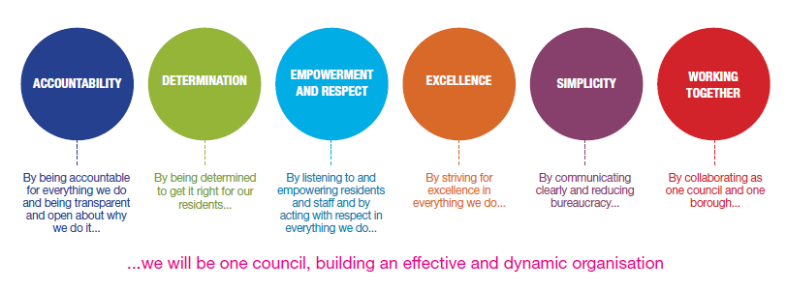

Our vision

Job title: Senior Education Psychologist (AEP)
Grade/Salary: Soulbury Scale B, 4-6, plus up to 3 SPA
Reports to: Principal Educational Psychologist
Post number:

Overview
To provide high-quality educational psychology services that improve outcomes for children and young people aged 0 to 25 years. The postholder will undertake statutory and non-statutory work, provide consultation and intervention at individual, group and systemic levels, support inclusion and SEND reforms, contribute to service development, and provide professional leadership within the Educational Psychology Service.
The Senior Educational Psychologist will be expected to lead areas of strategic development, support the delivery of traded and statutory services, supervise colleagues and trainees, and contribute to the development of psychologically informed practice across education, health and care systems.

Key responsibilities:

1. Psychological Assessment and Intervention
- Undertake psychological assessments of children and young people presenting with a range of learning, developmental, emotional, behavioural and social needs.
- Formulate psychologically informed understandings using evidence-based and person-centred approaches.
- Deliver consultation, intervention and review work with children, families and professionals.
- Provide advice and recommendations that support inclusion, participation and positive outcomes.
- Apply psychological theory and research to complex casework.

2. Statutory Duties
- Contribute to Education, Health and Care Needs Assessments (EHCNAs), producing high-quality psychological advice within statutory timescales.
- Contribute to SEND Tribunal and mediation processes as required.
- Ensure all statutory work complies with current legislation and the SEND Code of Practice.

3. Consultation and Systems Work
- Deliver consultation to schools, settings, families and partner agencies, supporting schools in developing inclusive practices and evidence-based provision.
- Contribute to whole-school approaches to wellbeing, learning and inclusion.
- Support organisational change through psychological consultation and coaching.

4. Leadership and Service Development
- Contribute to strategic planning and service improvement initiatives.
- Develop and evaluate new ways of working in response to local and national priorities.
- Lead project work, working groups and service developments.
- Contribute to the promotion of equity, diversity and inclusion across the service.
- Work collaboratively with education, health and social care partners to improve early intervention and prevention.
- Promote psychologically informed approaches that strengthen inclusive practice.

6. Supervision and Workforce Development
- Provide supervision and support to Educational Psychologists, Assistant Educational Psychologists, Trainee Educational Psychologists and other staff as appropriate.
- Contribute to induction, mentoring and professional development programmes.
- Deliver training and workforce development activities.

7. Research and Evidence-Based Practice
- Maintain and apply knowledge of current research and national developments.
- Lead service evaluation and quality assurance activities.

8. Professional Standards
- Maintain registration with the Health and Care Professions Council (HCPC) and Adhere to HCPC Standards of Proficiency and Standards of Conduct, Performance and Ethics.
- Comply with British Psychological Society professional guidance.

Special conditions:
This post is politically restricted.
This post may be subject to the DBS checking process.
Driving Licence will be subject to checking with the DVLA. It is a council requirement to have business use car insurance and a valid MOT certificate (For cars over 3 years old).

Prepared by: Tara Smith
Date: 21/9/2026

Person specification - Essential criteria:

Qualifications and experience
A good honours degree (minimum 2:1) in Psychology
Eligibility for Graduate Basis for Chartered Membership (GBC) with the British Psychological Society
Postgraduate Doctorate or recognised qualification in Educational Psychology.
Registration as a Practitioner Psychologist with the HCPC.
Enhanced DBS clearance
Significant post-qualification experience as an Educational Psychologist.
Experience of supervising Educational Psychologists, Trainee EPs or Assistant EPs.
Experience of leading projects or strategic developments.
Comprehensive knowledge of child development and psychological theory.
Detailed knowledge of SEND legislation and guidance
Understanding of inclusion and equalities legislation
Commitment to improving outcomes for children and young people.
Skills and abilities
Excellent written communication and report-writing skills.
Strong interpersonal and consultation skills.
Ability to manage competing demands and prioritise workloads
Ability to work collaboratively as part of a multidisciplinary team.
Ability to work autonomously and collaboratively
Strong presentation and training skills
Competence in the use of technology and digital systems


