Heavy Goods Vehicle Mechanic

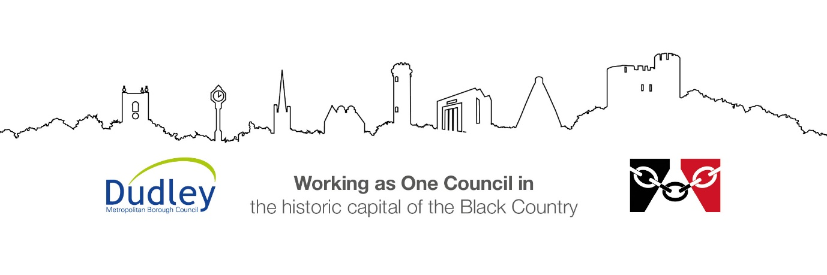

DMBC Operating Model 2024 - Vision:

A community-focused, financially resilient, collaborative, and sustainable council delivering the services required to support and meet the essential needs of residents, businesses, and the local economy.
Case for Change July 2024

Our Values:
Our values describe what we stand for and how we operate, and we expect our values to be lived and role-modelled throughout our organisation.

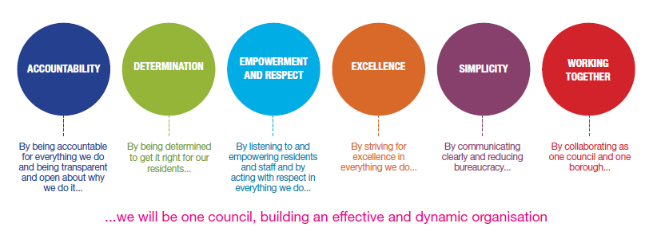
Job Description

Job Title: | Heavy Goods Vehicle Mechanic
Grade and Salary: | Grade 8 £36,581 to £39,481
Reports to: | Workshop Supervisor
Post Number: | DUE421

Role Purpose:
To assist the Transport Manager in providing a high-quality vehicle maintenance service that is safe, compliant and sustainable that allow Dudley MBC employees to carry out their roles in an efficient manner.

Specific Responsibilities:
- To inspect, service and repair the Councils fleet of heavy goods vehicles to include specialist body /equipment work and carry out of periodic routine roadworthiness inspections to legal requirements and standards laid down by the Driver & vehicle Standards Agency (DVSA) and Dudley MBC requirements including those necessary to pass MOT tests and maintain the councils Operators Compliance Score as green.

- To inspect, service and repair the Councils fleet of light goods vehicles to include specialist body /equipment work, and carry out of periodic routine roadworthiness inspections. To legal requirements and standards laid down by the Driver & vehicle Standards Agency (DVSA) and Dudley MBC requirements including those necessary to pass MOT tests.

- To ensure repairs and maintenance operations on all vehicles specialist body /equipment are carried out at a high standard and in accordance with manufactures instructions and standard times.

- To investigate and diagnose the cause of vehicle and specialist body /equipment defects, carry out the appropriate multi skill repairs to mechanical, electrical, electronic, hydraulic systems and body refurbishment work.

- To attend sites within Dudley MBC to facilitate break down repairs.

- Identify the need and specify replacement parts through the relevant electronic, hard copy catalogues.

- To interpret and implement technical service instruction data and manufactures modifications including understanding and interpreting complex and intricate wiring diagrams/technical drawings regarding electrical, mechanical, hydraulic and pneumatic systems.

- To participate in the delivery of vehicle maintenance services outside of the normal Monday to Friday shift working patterns to support the winter gritting operations.

- Complete and certify that all work is carried out on Inspection Sheets/Job cards to the relevant legislative requirements and is of the highest standards.

- Use of a range of technology based equipment including diagnostic, testing/inspection, hand held devices, internet resources and specialist software in addition to updating the status of repairs on the Councils fleet management system.

- Ensure that safe working practices are upheld in accordance with the Health & Safety at work act, the Council Safety Policies and site instructions. Always ensure that a safe working environment is maintained and the area is kept clean and tidy.

- Ensure all tools are inspected and they are safe to use and the job activity has been risk assessed adequately.

- Joint responsibility for the mentoring and development of modern Apprentices within the workshop to ensure they reach their full potential.

- Contribute to the safe and efficient operation of the council’s vehicle/plant fleet

Key Responsibilities:

- To be accountable for and promote equality, diversity and community cohesion to meet Group, Department and Function objectives. All employees have a responsibility not only for their own behaviour, but also for others regarding equality of opportunity. Any incident must be reported.

- To participate in a Performance Review and Development meeting and undertake a plan of training where necessary. Develop his/her own skills and expertise in a professional manner.

- In addition to all the responsibilities listed above, all employees must be flexible in their approach and undertake other duties that are commensurate with post holder’s level, wherever they may be, to achieve the objectives of the Group.

- To represent the Council and Group in a professional manner meeting the Corporate and Group aims. To comply with Group and Corporate policies.

- If appropriate to be responsible for the recruitment and performance management of designated teams and individuals in accordance with Corporate and Group aims and management style.

- To comply with the council’s financial regulation and standing orders

- To actively promote Dudley’s commitment to safeguarding and promoting the welfare of children, young people and vulnerable adults at a level appropriate to this group.

- Employees must comply with health and safety legislation and will be required to comply with the Council’s Health and Safety Policies. All employees must ensure that they take reasonable care of their own health and safety as well as the health and safety of any person that is affected by their actions. Where the Council has a statutory duty with regard to health and safety you are required to co-operate with the Council and its managers and officers so far as necessary to enable the Council to meet that duty. This includes using equipment and substances in accordance with training and instruction and the reporting of serious dangers to your own or others safety

- To be responsible for adhering to legislative requirements and Council Policies and Procedures including, but not exclusively health & safety, Data Protection and Internet/Email use.

- Equality – the Council is committed to ensuring equality of opportunity and to the principle that employees should be entitled to work in an environment free from intimidation and harassment. All employees have a responsibility not only for their own behaviour, but also for others regarding equality of opportunity. Any act of discrimination must be avoided and incident reported accordingly.

Special Conditions:

This post is subject to the DBS checking process.

Driving Licence will be subject to checking with the DVLA.

This post requires a Pre-Employment Medical Assessment and an annual health review.

The post holder is required to work onsite 5 days per week

Prepared by: | Stuart Edwards Fleet Transport Manager
Date: | September 2026

Essential criteria:
Person Specification
Qualifications and Experience |  | Application form | Technical assessment | Interview
 | Significant experience of inspecting, diagnosing, repairing and maintaining a range of light and heavy commercial vehicles. (Essential) | √ |  | √
 | Experience of inspecting, diagnosing, repairing and maintaining a range of specialist bodies. (Desirable) | √ |  | √
 | City and Guilds Level 1,2,3 in heavy vehicle repair and maintenance Certificate, or NVQ Level 3, or similar, or equivalent considerable experience and training may be considered. (Essential) | √ |  | √
 | LGV Category C licence (or willing to be trained and pass within 6 months of employment). (Essential) | √ |  | √
 | Evidence of CPD; Vehicles, equipment / manufactures training courses. (Desirable) | √ |  | √
 | GSE Qualifications A to D in Maths and English.  (Desirable) | √ |  | √
Skills and abilities
 | Proven commitment to public service and the ability to champion equality, diversity and inclusion and embedding these as core values | √ |  | √
 | Able to communicate effectively with others.  (Essential) | √ |  | √
 | Able to read, interpret and assimilate technical information to aid diagnostics, repair and maintenance of a range of commercial vehicles both light and heavy. (Essential) | √ |  | √
 | Able to organise own work priorities to meet performance targets. (Essential) | √ |  | √
 | Knowledge of the application and practice of Health & Safety legislation with a vehicle maintenance environment. (Essential) | √ |  | √
 | Equality Issues, Able to identify when discrimination is taking place in the workplace and take appropriate action where discrimination is identified. (Essential) | √ |  | √
 | Able to undertake physical repair of vehicles in workshop and outside environments and undertake the associated moving and lifting of heavy components. (Essential) | √ |  | √
 | Ability to work unsupervised and as part of a team.  (Essential) | √ |  | √
 | To have a flexible approach to work, being self-motivated and able to respond positively to all situations and a willingness to embrace change. (Essential) | √ |  | √
 | The post holder must be flexible in their working arrangements as on occasion evenings and weekends may be required. (Essential) | √ |  | √
 | A willingness to undertake further training.  (Essential) | √ |  | √
 | Able to adopt Dudley MBC core values and behaviours of Accountability, Determination, Empowerment and Respect, Excellence, Simplicity and Working Together. (Essential) | √ |  | √

