Job Description
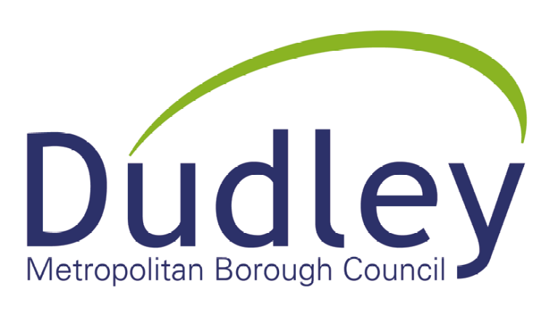
Job Title | Team Manager (Electrical) |  |  | Directorate |  | Housing & Communities
Post Number | PL41 |  |  | Division |  | Asset Management
Grade | 12 | Salary | £49764-£52805 |  | Section | Electrical Compliance

Reports To | Compliance Manager

Purpose of the Job
This role will manage the delivery of a number of electrical Compliance needs with key focus on Electrical Installation Condition Reports and associated works across DBMC’s portfolio plus follow up projects within Electrical Safety workstreams providing management and control over planning, design and construction across a significant Portfolio of UK buildings.
The projects are extremely high profile within the business and will have a meaningful impact on the business., financial management and business support teams, including health & safety staff, to ensure frontline services are delivered to the highest standards, achieving service plan targets and meeting internal and external customers needs.

To assist the Compliance Manager in the delivery of several compliances needs, plus follow up projects within an Electrical Division.
To ensure the Council fulfils its statutory and periodic maintenance regimes and remedial and improvement works are recorded, prioritised according to risk, and duly acted upon.

Ensuring the safety and compliance of all housing electrical installations in line with Policy, Procedure, Codes of practice and legislation

Specific Accountabilities
- To ensure all Duty holders who hold legal responsibility to ensure, as far as reasonably practicable, the health, safety, and welfare at work of all employees to matters within their control. This involves keeping electrical systems safe through correct design and installation and by using competent persons to carry out the work.

- To develop and manage services and systems that ensure the effective asset management of the Council’s housing stock and built assets in relation to all EICR’s & associated Services, while responding to occupier needs where appropriate and ensuring the working environment remains functional and is fit for its intended purpose.

- To oversee the performance, conduct training and competence of staff and direct trades under your direct control ensuring all corporate and Directorate HR policies, and directives are carried out.

- Support the Group Manager to seek out opportunities to improve service efficiency and sustainability and to minimise the divisions operational activities impact on the environment, through major construction projects and depot redevelopments.

- To show effective leadership of a large compliance section by way of example with regards to your personal conduct and the motivation and mentoring of staff and direct trades.

- To be a key reference point of contact for complex electrical and system related trouble shooting/problem solving demonstrating a high level of technical understanding and conceptual skill

- To annually review and update working Risk assessments and Method Statements and annual and periodic training is carried out in accordance with the recommendations.

- Support the Group Manager to seek out opportunities to improve service efficiency and sustainability and to minimise the divisions operational activities impact on the environment, through major construction projects and depot redevelopments.

- Be the project lead on engaging with internal stakeholders to ensure projects and designs are fit for purpose and will provide the Council with long-term service flexibility.

- Act as the Lead contact with external stakeholders, including design teams, Planning, community representatives and contractors.

- To manage large multi-disciplined teams with a wide variety of resources and large project budgets, contributing to annual service plans, setting service level objectives, managing individual and team performance, ensuring continuous service improvement and high levels of customer satisfaction.

- To ensure the Council fulfils its statutory and service duties to maintain its buildings (both Housing and Corporate) safely and effectively; ensuring statutory and periodic maintenance regimes are implemented and maintained in accordance with Legislation and Approved Codes of Practice.

- To design, adapt and deliver a wide range of varied and complex services, across the team’s portfolio; including maintaining continuous professional development across many portfolios to enable the Group Manager to reassign Team Managers to different portfolios and teams at short notice.

- To prepare and deliver regular training to team members on sector developments, leadership and coaching skills, technical updates, re-engineered processes and service improvements.

- To prepare and deliver regular presentations to Corporate Board, Chief Officers, stakeholders and customers on sector developments, technical updates, re-engineered processes and service improvement proposals.

- To manage, maintain and review the strategic repairs and improvement partnership with internal and external services ensuring the partnership delivers to the highest standards.

- To manage very large budgets and the delivery of capital and revenue work programmes in relation to the built environment and property requirements for the Council incorporating processes for informing, preparing, monitoring and commissioning services

- To represent the Council on relevant external and professional trade bodies, committees and projects as required.

- To design, adapt and deliver a wide range of projects of varying complexity, including individual revenue and capital projects, to large scale programmes and whole scale service change programmes.

- To develop service plans that contribute to the delivery of Corporate objectives and the Council Plan.

- To ensure the Council fulfils its statutory requirements to comply with a wide range of Health, Safety and Welfare legislation, including the Construction (Design and Management) Regulations 2015 for any construction works.

- Develop new and traded services opportunities for the service and wider Council, that promotes the Dudley brand, generates income for the Council and maintains community cohesion.

- To maintain a live document register of competency of all relevant qualifications of Quality Supervisors, Engineers and testing and inspecting personnel both directly employed and employed by the councils contractors as per our NICEIC requirement ensuring the Directorates Electrical specification is carried out consistently in all properties.

- To undertake effective project management to identify, sequence and manage capital spend priorities; ensuring they are delivered on time, demonstrate value for money to agreed performance standards and are within budget; liaising with fellow Team Managers to ensure that all work commissioned is agreed, programmed and delivered to the highest standards.

- To ensure that the Council fulfils its statutory and service duties to maintain its buildings and sites safely and effectively; ensuring statutory and periodic maintenance regimes are implemented and hazard registers are maintained; specifically in relation to housing premises and asset management, including monitoring of statutory requirements, e.g. Fire Risk Assessments and associated works , Manage programme of surveys with external supplier, Manage programme of survey reviews with internal staff, Record surveys on data base, Collate and record remedial actions on database, Close out remedial works actions on database, Update Property compliance scorecard

- To provide construction, financial or property related technical and advisory services including continuous professional development to maintain awareness and knowledge of legislation and best practice relevant to the Team Manager’s service area.

- To manage the expectations of new and existing customers; building and maintaining relationships including engaging and negotiating as appropriate; ensuring project progress is communicated and that problems are addressed in a timely and professional manner.

- To undertake consultation and complex negotiations with strategic external organisations such as other public bodies, joint venture partners, consultants, central and local government bodies, trade unions, inspectors and private sector companies.

- Where required by the Group Manager, attend Council meetings, local resident groups and meetings with Elected Members and Community Forums.

- Where required by the Group Manager, prepare robust financial and performance management reports to ensure the effective management and development of the service.

- Where required by the Group Manager, representing the service on the Council’s Major Emergency Plan and ensuring satisfactory out of hours arrangements are in place to allow continuous delivery of essential services to building users and service providers.

- Where required by the Group Manager, investigate and respond to complaints in relation to Council services, which may include representation to the Ombudsman Service.

- Conducting such other work as may be assigned by the Group Manager as necessary.

Key Accountabilities
- To be accountable for and promote equal opportunity, diversity and community cohesion to meet Council, Directorate and Service objectives. All employees have a responsibility not only for their own behaviour, but also for others regarding equality of opportunity. Any incident must be reported.
- To participate in a Performance Review and Development meeting and undertake a plan of training where necessary. Develop his/her own skills and expertise in a professional manner.
- In addition to all the responsibilities listed above, all employees must be flexible in their approach and undertake other duties that are commensurate with post holder’s level, wherever they may be, to achieve the objectives of the Directorate.
- To represent the Council and Directorate in a professional manner meeting the Corporate and Directorate aims. To comply with Directorate and Corporate policies.
- If appropriate to be responsible for the recruitment and performance management of designated teams and individuals in accordance with Corporate and Directorate aims and management style.
- To comply with the council’s financial regulation and standing orders
- To actively promote Dudley’s commitment to safeguarding and promoting the welfare of children, young people and vulnerable adults at a level appropriate to this role and setting.
- Employees must comply with health and safety legislation and will be required to comply with the Council’s Health and Safety Policies. All employees must ensure that they take reasonable care of their own health and safety as well as the health and safety of any person that is affected by their actions.
- To be responsible for adhering to legislative requirements and Council Policies and Procedures including, but not exclusively health & safety, Data Protection and Internet/Email use

Special Conditions | This post is subject to the DBS checking process  Driving Licence will be subject to checking with the DVLA. It is a council requirement to have Business Use Car Insurance and a valid MOT certificate (For cars over 3 years old)
Car Allowance | Mileage
Prepared By | Steve Ward
Date | 19th February 2025

