DSPP Joint Business Support Officer
DSPP Joint Business Support Officer



DMBC Operating Model 2024 - Vision:

A community-focused, financially resilient, collaborative, and sustainable council delivering the services required to support and meet the essential needs of residents, businesses, and the local economy.
Case for Change July 2024

Our Values:
Our values describe what we stand for and how we operate, and we expect our values to be lived and role-modelled throughout our organisation.

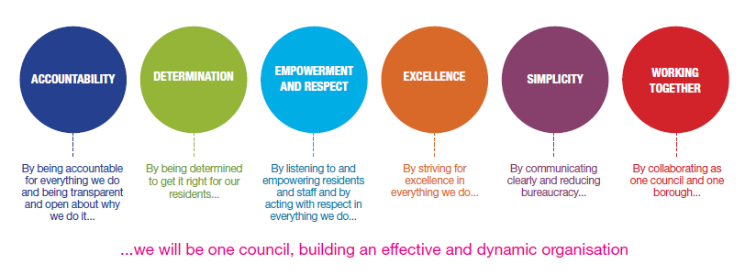
Job Description

Job Title: | DSPP Joint Business Support Officer
Grade/Salary: | Grade 6
Reports to: | Joint Safeguarding Business Manager
Post Number: | AC5

Role Purpose:
To support the delivery of DSPP by providing high quality business support to the partnership and associated sub groups / work streams and activity
Scope of the job
- To support and co-ordinate the activities of the Local Safeguarding People Partnership Arrangements (DSPP), and its sub groups, arranging and coordinating and minuting the meetings of the Partnership and its sub groups and training offer
- To support the Learning and Development coordinator and Development Officer in collating and producing reports and documentations including Business Plans; statistical information; monitoring and quality assurance processes
- The post holder is required to develop effective working relationships across the partnership including communicating with senior officers and elected members
The post holder is required to deliver the requirements of the role so as to develop the visibility and reputation of the DSPP

Specific Responsibilities:

The postholder is responsible for coordinating and facilitating the meetings of the Dudley Safeguarding People Partnership (DSPP) and its sub-groups by establishing and maintaining effective administrative systems. This includes organising meetings, booking venues, circulating agendas, taking and distributing minutes within agreed timescales, and maintaining action logs and forward plans. Acting as the main point of contact for agencies wishing to contribute to DSPP agendas, the postholder ensures effective communication and coordination across partner organisations. The role involves responding promptly to correspondence, telephone calls, emails and requests for information, while using initiative and agreed procedures to manage routine enquiries and correspondence efficiently.

The postholder provides high quality business and administrative support to the DSPP, supporting members of the Partnership in responding to inspections, regulatory requirements and external reviews, including peer reviews, to evidence the Board’s activities and improve outcomes for the people of Dudley. They proactively collate and maintain information required for inspections and contribute to the review of legislative changes by gathering and disseminating relevant local, regional and national guidance, bulletins, government circulars and newsletters.

A key aspect of the role is arranging and servicing DSPP and subgroup meetings in accordance with agreed business standards, including identifying meeting dates, organising venues and refreshments, distributing papers, minuting meetings, transcribing and circulating minutes, and ensuring action logs are maintained and updated. The postholder works closely with the Chairs of the Partnership and its sub-groups to ensure agendas are agreed in sufficient time and supporting papers are received and circulated ahead of meetings.

The role also provides high-quality business support for DSPP projects, awareness raising activities, events and Board development days, including supporting the Child Safeguarding Practice Review (CSPR) and Safeguarding Adult Review (SAR) processes. This includes providing key business support throughout CSPR and SAR activity, ensuring effective administration, coordination and governance arrangements are in place. In addition, the postholder supports the Children and Adults Leads in maintaining and updating the DSPP website, ensuring it provides an accurate, professional and accessible representation of the Partnership, its business units and partner organisations.

The postholder is responsible for managing and prioritising their own workload to ensure all tasks and projects are completed within required timescales, handling sensitive and personal information in accordance with relevant legislation and organisational requirements, and working collaboratively as a member of the DSPP Business Unit to produce high-quality and accurate work. The role also requires undertaking any other duties commensurate with the grade of the post in order to support the effective delivery of DSPP functions.

Key Responsibilities:

- To be accountable for and promote equality, diversity and community cohesion to meet Council, Directorate and Service objectives. All employees have a responsibility not only for their own behaviour, but also for others regarding equality of opportunity. Any incident must be reported.
- To participate in a Performance Review and Development meeting and undertake a plan of training where necessary. Develop his/her own skills and expertise in a professional manner.
- In addition to all the responsibilities listed above, all employees must be flexible in their approach and undertake other duties that are commensurate with post holder’s level, wherever they may be, to achieve the objectives of the Directorate.
- To represent the Council and Directorate in a professional manner meeting the Corporate and Directorate aims. To comply with Directorate and Corporate policies.
- To comply with the council’s financial regulation and standing orders
- To actively promote Dudley’s commitment to safeguarding and promoting the welfare of children, young people and vulnerable adults at a level appropriate to this group.
- Employees must comply with health and safety legislation and will be required to comply with the Council’s Health and Safety Policies. All employees must ensure that they take reasonable care of their own health and safety as well as the health and safety of any person that is affected by their actions.

To be responsible for adhering to legislative requirements and Council Policies and Procedures including, but not exclusively health & safety, Data Protection and Internet/Email use.
- To actively promote Dudley’s commitment to safeguarding and promoting the welfare of children, young people and vulnerable adults at a level appropriate to this group.

- Employees must comply with health and safety legislation and will be required to comply with the Council’s Health and Safety Policies. All employees must ensure that they take reasonable care of their own health and safety as well as the health and safety of any person that is affected by their actions.

- To be responsible for adhering to legislative requirements and Council Policies and Procedures including, but not exclusively health & safety, Data Protection and Internet/Email use.

Special Conditions:

This post is subject to the Enhanced DBS checking process

The post holder is required to work onsite 3 days per week

Prepared by: | Dave Bache
Date: | 06 August 2026

Essential criteria:
Person Specification
Qualifications and Experience |  | Application form | Technical assessment | Interview
 | GCSE Maths and English Grades A – C or equivalent
 | Significant administration experience including overseeing systems to monitor progress
 | Significant experience of supporting business projects
 | Experience of managing personal and sensitive data
 | Experience of working with budgetary information and systems.
 | Experience of working with statistical data
Skills and abilities
 | Proven commitment to public service and the ability to champion equality, diversity and inclusion and embedding these as core values
 | Excellent oral and written communication skills.
 | Computer literate with excellent keyboard skills.
 | Ability to use the Microsoft Office Suite including Word, Excel, Access, PowerPoint, Outlook and Schedule.
 | Strong organisational skills and ability to work simultaneously across several work streams/projects
 | Good time management with the ability to manage and prioritise own workload
 | Tactful and diplomatic with the ability to maintain confidentiality at all times.
 | Ability to communicate at all levels and maintain good working relationships with members of the public, Council staff, staff from other agencies and Elected Members.
 | Ability to minute meetings
 | Good inter-personal skills.
 | Ability to act on own initiative and problem solve.
 | Ability to produce statistical information for monitoring purposes
 | A knowledge of Equality & Diversity
 | Self -motivated with a commitment to providing a quality service.
 | Ability to deal sensitively with competing and complex situations and make decisions
 | Flexible towards the needs of the service
 | Commitment to Equal Opportunities and promoting children’s welfare

