Job Title



DMBC Operating Model 2024 - Vision:

A community-focused, financially resilient, collaborative, and sustainable council delivering the services required to support and meet the essential needs of residents, businesses, and the local economy.
Case for Change July 2024

Our Values:
Our values describe what we stand for and how we operate, and we expect our values to be lived and role-modelled throughout our organisation.

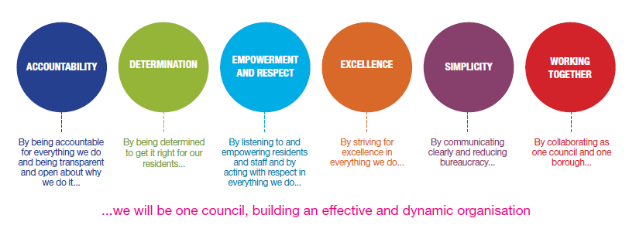
Job Description

Job Title: | Arts Educator
Grade/Salary: | Grades 1 – 6, £25,364 to £36,351 plus QTS allowance if applicable
Reports to: | Dudley Performing Arts Head of Service
Post Number: | 1

Role Purpose:
To undertake education duties as identified by the strategic direction of Dudley Performing Arts along with the needs of its clients.

Specific Responsibilities:

- Arts Educator are responsible for delivering high-quality educational activities in accordance with agreed schemes of work and the pedagogical approaches of Dudley Performing Arts (DPA), including assessment, planning, recording and reporting processes. The postholder will uphold the Professional Standards for Arts Educators and work in accordance with DPA policies, procedures and professional expectations at all times. The role requires the consistent delivery of all scheduled teaching and learning activities, adherence to agreed timetables and operational procedures, and the effective management of resources to support high-quality provision. Arts Educators will take responsibility for their own continuing professional development and actively engage in performance management and appraisal processes to enhance their practice and contribute to organisational improvement. Working collaboratively with colleagues and stakeholders, the postholder will support the development and promotion of new programmes and services for DPA and its clients, including participation in promotional activities and, where required, evening teaching engagements. The Arts Educator will contribute to maintaining and strengthening positive relationships with clients and partners, supporting the continued commissioning and growth of DPA's services. The postholder will prepare students for examinations and assessments as appropriate, ensuring learners are supported to achieve their full potential. In addition, they will participate flexibly in alternative timetable arrangements, including performances, productions, events and other programmed activities, as directed, contributing to the wider artistic and educational aims of Dudley Performing Arts. The postholder will attend staff meetings and statutory training as required (e.g. safeguarding, health and safety) as demanded by legislation, and any other duties deemed appropriate from time to time, by Head of Dudley Performing Arts and or Curriculum Leaders.

Key Responsibilities:

- To be accountable for and promote equality, diversity and community cohesion to meet Group, Department and Function objectives. All employees have a responsibility not only for their own behaviour, but also for others regarding equality of opportunity. Any incident must be reported.

- To participate in a Performance Review and Development meeting and undertake a plan of training where necessary. Develop his/her own skills and expertise in a professional manner.

- In addition to all the responsibilities listed above, all employees must be flexible in their approach and undertake other duties that are commensurate with post holder’s level, wherever they may be, to achieve the objectives of the Group.

- To represent the Council and Group in a professional manner meeting the Corporate and Group aims. To comply with Group and Corporate policies.

- If appropriate to be responsible for the recruitment and performance management of designated teams and individuals in accordance with Corporate and Group aims and management style.

- To comply with the council’s financial regulation and standing orders

- To actively promote Dudley’s commitment to safeguarding and promoting the welfare of children, young people and vulnerable adults at a level appropriate to this group.

- Employees must comply with health and safety legislation and will be required to comply with the Council’s Health and Safety Policies. All employees must ensure that they take reasonable care of their own health and safety as well as the health and safety of any person that is affected by their actions.

- To be responsible for adhering to legislative requirements and Council Policies and Procedures including, but not exclusively health & safety, Data Protection and Internet/Email use.

Special Conditions:

This post is subject to the DBS checking process

Driving Licence will be subject to checking with the DVLA. It is a council requirement to have Business Use Car Insurance and a valid MOT certificate (For cars over 3 years old)

Prepared by: | Claire Pennycooke
Date: | 6th August 2026

Essential criteria:
Person Specification
Qualifications and Experience |  | Application form | Technical assessment | Interview
 | Ability to plan, deliver and evaluate engaging, high-quality arts learning experiences for children and young people of differing ages, abilities and backgrounds. | √ |  | √
 | High Level performance skills and subject knowledge in a relevant arts discipline, with the ability to inspire and motivate learners. | √ | √ | √
 | Strong classroom, rehearsal and behaviour management skills, creating a safe, inclusive and positive learning environment. | √ |  | √
 | Understanding of safeguarding responsibilities and the ability to promote the welfare of children and young people at all times. | √ |  | √
 | Excellent communication and interpersonal skills, with the ability to build positive relationships with children, parents, schools and partners. | √ |  | √
 | Strong organisational and time management skills, including the ability to manage competing priorities and work across multiple settings. |  |  | √
 | Ability to adapt teaching approaches to meet the diverse needs of individuals and groups, including those with additional needs or disabilities. | √ |  | √
 | Ability to support public performances, events, examinations and showcases, including occasional evening and weekend work where required. |  |  | √
Skills and abilities
 | Proven commitment to public service and the ability to champion equality, diversity and inclusion and embedding these as core values |  |  | √
 | Ability to use creativity and initiative to develop innovative projects, performances and learning opportunities. | √ |  | √
 | Competence in maintaining accurate records, reports and assessment information. |  |  | √
 | Ability to work collaboratively as part of a wider team, contributing to the achievement of organisational and educational objectives. | √ |  | √
 | Ability to represent Dudley Performing Arts professionally and positively, promoting its values, services and reputation. |  |  | √

