Lead Child Protection Practitioner



DMBC Operating Model 2024 - Vision:

A community-focused, financially resilient, collaborative, and sustainable council delivering the services required to support and meet the essential needs of residents, businesses, and the local economy.
Case for Change July 2024

Our Values:
Our values describe what we stand for and how we operate, and we expect our values to be lived and role-modelled throughout our organisation.

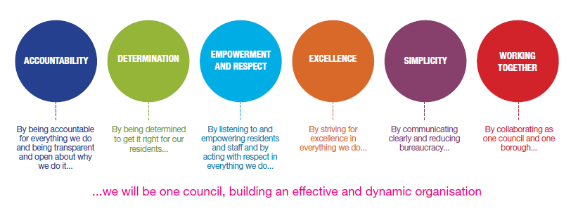
Job Description

Job Title: | Lead Child Protection Practitioner
Grade/Salary: | 12
Reports to: | Senior LCPP
Post Number:

Role Purpose:
Responsible for and lead decision-maker for all Child Protection Enquiries and Child Protection Conferences.

Lead child protection practitioners will hold an extremely varied, highly complex, highly challenging and demanding caseload and will play a key role in supporting best practice development, through sharing expertise and providing support and development for other practitioners.

You will use your significant social work expertise and a clear child focus to secure the very best for our children, young people, and families. You will chair child protection conferences in accordance with the Children Act 1989 and Working Together 2023, and to ensure that child protection plans are developed and reviewed to ensure good outcomes for children and young people.

Practice social work in a transparent, accountable and safe way in accordance with professional standards and ethics.

To be practice leader, and to lead the development of high quality of child protection practice across the service and across the borough.

To support all frontline practitioners, and to be aware of and manage performance in relation to child protection.

Specific Responsibilities:

Experience:

It is essential that the post holder has:

• Significant experience of working with children and young people in a statutory social care setting, including those in need of safeguarding and looked after and adopted children and young people.
• Demonstrable experience of leading practice and evidencing strong outcomes within safeguarding and child protection case work.

• Significant experience achieving results within a statutory social work role.

• Demonstrable experience of supporting others in a social work/social care role.

• Significant experience of supporting ASYE social workers, social work students in their development.

• Significant experience in making highly complex decisions relating to social service provision for children, young people and their families within Dudley

Knowledge, Skills and Abilities:

It is essential that the post holder has:

• Significant Knowledge and understanding of relevant legislative and regulatory framework and Government initiatives relating to children’s services, including safeguarding, and the needs of looked after children and those placed for adoption.

• The tenacity to repeatedly meet service expectations regarding key performance indicators.

• Extremely High Emotional resilience, that is, the ability to perform effectively during periods of change.

• Willingness to enhance personal performance by seeking out constructive feedback, gaining insight and awareness of personal strengths and challenges.

Additional Information.

• To provide accessible and visible leadership for the service in relation to child protection, and be the first point of contact for all staff to provide advice and guidance.

• To be a recognised expert in child protection, and to offer specialist knowledge and support to others in a particular area.

• To lead the practice and decision-making of the Multi-Agency Child Protection Team.

• To develop practice through oversight and quality assurance of child protection practice, observations of practice and appraisal.
• To be responsible for the professional supervision, guidance, and reflective practice of child protection.

• To support and develop knowledge and skills in line with Dudley’s practice framework

• To facilitate regular Group Supervision around child protection to foster collaborative multi-agency working.

• To lead practice development in child protection, and to develop a culture of learning and evidence-based practice.

• Deliver training sessions and workshops to support the development of effective, consistent child protection practice across the service and the Dudley Safeguarding Partnership.

• To work collaboratively with partner agencies, within the children’s directorate and in the voluntary sector to ensure multi-agency assessment, planning, intervention and review

• To ensure that the Service seeks to involve parents/carers and young people in the planning of services and review processes, including actively seeking their views and their participation.

Key Responsibilities:

- To be accountable for and promote equality, diversity and community cohesion to meet Group, Department and Function objectives. All employees have a responsibility not only for their own behaviour, but also for others regarding equality of opportunity. Any incident must be reported.

- To participate in a Performance Review and Development meeting and undertake a plan of training where necessary. Develop his/her own skills and expertise in a professional manner.

- In addition to all the responsibilities listed above, all employees must be flexible in their approach and undertake other duties that are commensurate with post holder’s level, wherever they may be, to achieve the objectives of the Group.

- To represent the Council and Group in a professional manner meeting the Corporate and Group aims. To comply with Group and Corporate policies.

- If appropriate to be responsible for the recruitment and performance management of designated teams and individuals in accordance with Corporate and Group aims and management style.

- To comply with the council’s financial regulation and standing orders

- To actively promote Dudley’s commitment to safeguarding and promoting the welfare of children, young people and vulnerable adults at a level appropriate to this group.

- Employees must comply with health and safety legislation and will be required to comply with the Council’s Health and Safety Policies. All employees must ensure that they take reasonable care of their own health and safety as well as the health and safety of any person that is affected by their actions.

- To be responsible for adhering to legislative requirements and Council Policies and Procedures including, but not exclusively health & safety, Data Protection and Internet/Email use.

Special Conditions:

This post is subject to the DBS checking process (delete if not applicable)

Driving Licence will be subject to checking with the DVLA. It is a council requirement to have Business Use Car Insurance and a valid MOT certificate (For cars over 3 years old) (delete if not applicable)

The post holder is required to work onsite 3 days per week

Prepared by: | Cornelia Heaney Practice Safeguarding and QA
Date: | 13/10/2026

Essential criteria:
Person Specification
Qualifications and Experience |  | Application form | Technical assessment | Interview
 | Considerable experience within children's social care working with children and young people in a statutory social care setting which must include child protection and protecting children from significant harm | x | x
 | Significant experience of achieving improved outcomes for children and young people. | x | x
 | Significant post qualifying experience. | x | x
 | Demonstrable experience in leading staff. |  | x
 | Demonstrable experience of successfully managing projects. |  | x
 | A professional qualification in social work. | x
 | Social Work England registration. | x
Skills and abilities
 | Proven commitment to public service and the ability to champion equality, diversity and inclusion and embedding these as core values | x | x
 | Credibility in a significant area of specialism. | x | x
 | Ability to transfer skills and lead service improvement in a variety of areas of service. | x | x
 | The tenacity to repeatedly follow through indictors of service and staff performance to secure the necessary improvement in service provision. | x | x
 | Extremely high emotional resilience, that is, the ability to perform effectively during periods of change and stress and working with extremely varied and highly complex and highly challenging and demanding cases. | x | x
 | Highly developed negotiating and/or persuasive skills | x | x
 | A knowledge of Equality & Diversity issues |  | x

