Recruitment & Talent Engagement Officer

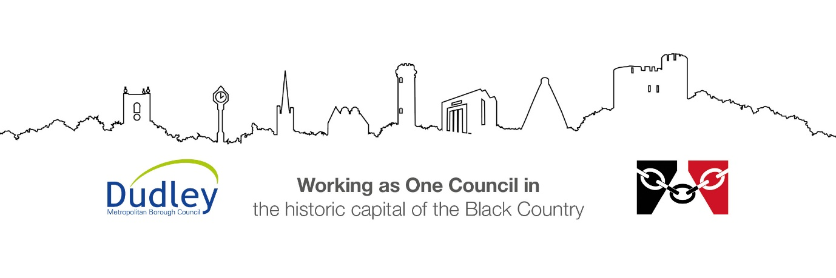

DMBC Operating Model 2024 - Vision:

A community-focused, financially resilient, collaborative, and sustainable council delivering the services required to support and meet the essential needs of residents, businesses, and the local economy.
Case for Change July 2024

Our Values:
Our values describe what we stand for and how we operate, and we expect our values to be lived and role-modelled throughout our organisation.

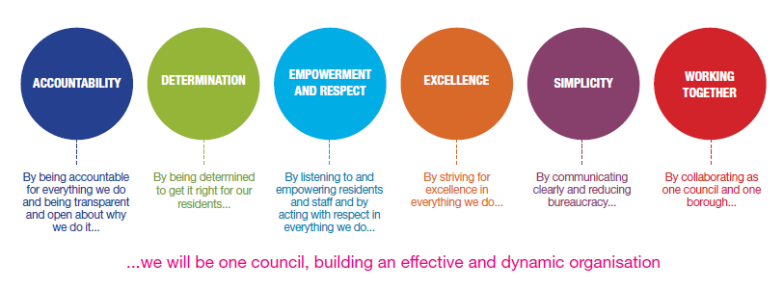
Job Description

Job Title: | Recruitment & Talent Engagement Officer
Grade/Salary: | Grade 8
Reports to: | Resourcing Admin Manager
Post Number: | SC063

Role Purpose:
To act as the first point of contact for prospective employees, providing a professional, responsive and customer-focused recruitment service that promotes the Council as an employer of choice.
The postholder will coordinate end-to-end recruitment administration from vacancy approval through to conditional offer stage, ensuring a smooth and positive candidate experience. They will work closely with hiring managers, advertising partners, HR and other internal stakeholders to attract high-quality candidates and support the delivery of the Council's workforce strategy.
The role will also have responsibility for promoting employment opportunities through social media and other attraction channels, enhancing the Council's employer brand and increasing engagement with potential applicants.

Specific Responsibilities:
- Act as the first point of contact for all recruitment-related enquiries from prospective applicants, employees and managers.
- Coordinate recruitment campaigns across a range of service areas.
- Prepare and publish vacancy advertisements on recruitment systems, websites and external job boards.
- Monitor recruitment inboxes and ensure timely responses to enquiries.
- Provide guidance to applicants regarding vacancies, application processes and recruitment timelines.
- Support managers in the preparation of job advertisements and recruitment documentation.
- Arrange interviews, assessment centres and recruitment events.
- Manage candidate communications throughout the recruitment process.
- Maintain accurate recruitment records and applicant tracking systems.
- Produce recruitment correspondence including invitations, outcome letters and conditional offers.
- Ensure recruitment activity complies with employment legislation, Council policies and equality requirements.
- Liaise with recruiting managers to ensure vacancies progress efficiently and within agreed timescales.
- Liaise closely with the HR Resourcing team to ensure candidates timely progression through the Council recruitment process and that recruitment takes place within existing Council policy and procedures.
- Provide day-to-day line management, supervision and support to Recruitment Officer(s), ensuring the delivery of a high-quality, customer-focused recruitment service.

Candidate Experience
- Deliver a professional and welcoming service to all prospective employees.
- Ensure candidates receive regular communication and a positive recruitment experience.
- Support applicants who require reasonable adjustments during the recruitment process.
- Promote diversity, equality and inclusion throughout all recruitment activities.
- Gather candidate feedback and identify opportunities to improve recruitment processes.
Attraction and Employer Branding
- Work with Communications & Public Affairs Team to support Development of engaging content to promote vacancies and careers within the Council.
- Manage and update recruitment-focused social media channels.
- Produce social media campaigns to attract candidates into hard-to-fill roles.
- Promote apprenticeships, graduate opportunities and career pathways.
- Attend recruitment fairs, community events and careers exhibitions.
- Support the development of marketing materials including brochures, digital content and promotional campaigns.
- Monitor the effectiveness of attraction campaigns and recommend improvements.
Advertising and Stakeholder Liaison
- Build and maintain positive working relationships with recruitment advertising agencies and media providers.
- Coordinate vacancy advertising across multiple platforms.
- Negotiate advertising placements and monitor expenditure against budgets.
- Review advertising performance and recommend the most effective recruitment channels.
- Work collaboratively with communications and marketing teams to maximise vacancy reach.
- Liaise with external suppliers regarding recruitment advertising, social media campaigns and employer branding initiatives.

Data Management and Reporting
- Contribute to the review, development and implementation of recruitment and talent attraction strategies to address workforce shortages, hard-to-fill vacancies and future workforce requirements
- Analyse workforce trends, labour market intelligence and recruitment performance data to produce workforce planning recommendations for Directors and Senior Leaders.
- Maintain accurate recruitment data and management information.
- To report and present findings on recruitment performance reports, workforce intelligence and improvement recommendations to senior leadership teams, transformation boards and workforce governance groups
- Produce regular reports on recruitment activity, advertising outcomes and candidate attraction metrics.
- Monitor key performance indicators such as time-to-hire, application volumes and source of candidates.
Key Responsibilities:

- To be accountable for and promote equality, diversity and community cohesion to meet Group, Department and Function objectives. All employees have a responsibility not only for their own behaviour, but also for others regarding equality of opportunity. Any incident must be reported.

- To participate in a Performance Review and Development meeting and undertake a plan of training where necessary. Develop his/her own skills and expertise in a professional manner.

- In addition to all the responsibilities listed above, all employees must be flexible in their approach and undertake other duties that are commensurate with post holder’s level, wherever they may be, to achieve the objectives of the Group.

- To represent the Council and Group in a professional manner meeting the Corporate and Group aims. To comply with Group and Corporate policies.

- If appropriate to be responsible for the recruitment and performance management of designated teams and individuals in accordance with Corporate and Group aims and management style.

- To comply with the council’s financial regulation and standing orders

- To actively promote Dudley’s commitment to safeguarding and promoting the welfare of children, young people and vulnerable adults at a level appropriate to this group.

- Employees must comply with health and safety legislation and will be required to comply with the Council’s Health and Safety Policies. All employees must ensure that they take reasonable care of their own health and safety as well as the health and safety of any person that is affected by their actions.

- To be responsible for adhering to legislative requirements and Council Policies and Procedures including, but not exclusively health & safety, Data Protection and Internet/Email use.

Special Conditions:

This post is subject to the DBS checking process (delete if not applicable)

Driving Licence will be subject to checking with the DVLA. It is a council requirement to have Business Use Car Insurance and a valid MOT certificate (For cars over 3 years old) (delete if not applicable)

The post holder is required to work onsite 3 days per week

Prepared by: | HR Business Partner
Date: | September 2026

Essential criteria:
Person Specification
Qualifications and Experience |  | Application form | Technical assessment | Interview
 | Experience of providing administrative support within a busy office environment.
 | Experience of coordinating recruitment or human resources processes.
 | Experience of providing excellent customer service
 | Experience of using Microsoft Office applications.
 | Experience of managing multiple priorities and deadlines
 | Experience of communicating professionally with a range of internal and external stakeholders
 | Experience of recruitment marketing and attraction campaigns
 | Experience of working with recruitment systems and applicant tracking software
 | Experience of supervising or line managing staff, including workload management, performance monitoring and employee development
 | Relevant Degree (or equivalent professional qualification) or be able to demonstrate an equivalent level of knowledge
 | GCSE English and Mathematics (Grade C/4 or above) or equivalent
 | Evidence of continuing professional development.
Skills and abilities
 | Proven commitment to public service and the ability to champion equality, diversity and inclusion and embedding these as core values
 | Excellent communication and interpersonal skills
 | Strong organisational and planning skills
 | Ability to build positive relationships with candidates, managers and external partners
 | Ability to create engaging written content for digital platforms
 | Strong attention to detail and accuracy
 | Good analytical and reporting skills
 | Ability to handle confidential information sensitively and professionally
 | Strong customer-focused approach

