Emotional Wellbeing Worker (EWW)

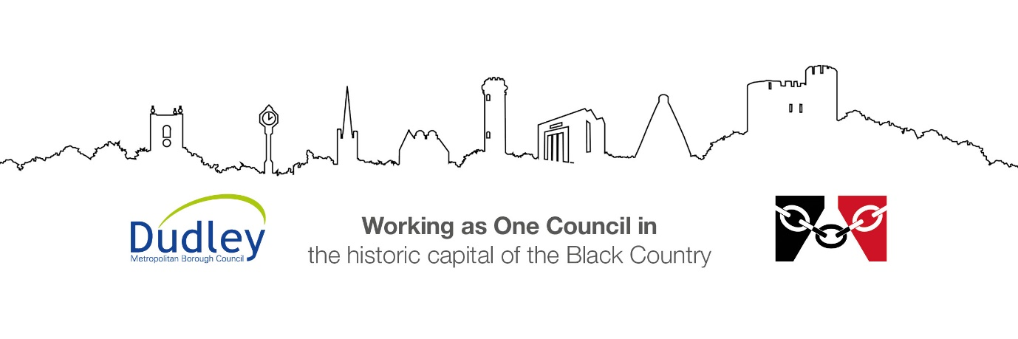

DMBC Operating Model 2024 - Vision:

A community-focused, financially resilient, collaborative, and sustainable council delivering the services required to support and meet the essential needs of residents, businesses, and the local economy.
Case for Change July 2024

Our Values:
Our values describe what we stand for and how we operate, and we expect our values to be lived and role-modelled throughout our organisation.

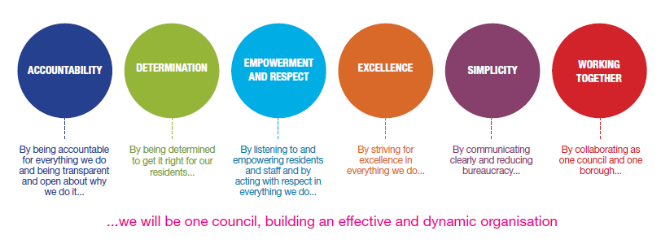
Job Description

Job Title: | Emotional Wellbeing Worker (EWW)
Grade/Salary: | 7
Reports to: | Service Manager/Team Manager/Supervisor
Post Number: | Click or tap here to enter text.

Role Purpose:
Dudley Childrens Service wants to ensure that all our Children in Care (CIC), Care Leavers and our Carers receive the right support at the right time to promote their emotional wellbeing.
Dudley Childrens Social Care undertook a service redesign which led to the development of Emotional Wellbeing Support (EWS) in October 2023. A more streamlined integration between Social Care and Health was required to offer a smoother pathway to children in care at the right time. A service specification drawn up between Health and Social Care agreed what was required to make a positive difference. The EWS offer is embedded within the Throughcare Service and provides direct links to the Child in Care and Fostering Teams. Additionally, EWS offers support/ advice and guidance to the Safeguarding Teams where there is a chid in care and via the annual Strengths and Difficulties Questionnaire (SDQ) reporting process.
The integrated emotional wellbeing support offer provides dedicated, timely support for children and young people who are experiencing emotional/behavioural/mental health difficulties. A holistic approach supports the reduction of potential placement breakdowns and ensures a better chance of placement stability, by offering consultation, advice and training to professionals and carers working with and caring for the young people. The model reflects a fluid and more flexible approach, with an open door throughout the child or young person’s journey providing some reassurance that they don’t need to repeat their ‘story’ when needing emotional wellbeing support.
The post holder will work within a team providing evidence-based emotional wellbeing interventions. This will be based around Cognitive Behaviour Therapy (CBT), Dyadic Developmental Psychotherapy (DDP), Dialectical Behaviour Therapy (DBT) and Trauma Informed Practice, to promote the emotional health and well-being of children, young people and families.
Partnership with internal and external agencies will be key to the role with the aim of improving relationships, building emotional resilience, and ensuring placement stability through appropriate strength-based interventions.
The post-holder will hold a caseload and work closely with their team and colleagues. This will include working across the service (where appropriate) and at the child’s/young person’s placement locality.

Specific Responsibilities Emotional Wellbeing Worker (EWW)

- To work as part of a team and other services where appropriate.

- Complete initial assessments, plans of therapy and deliver interventions under guidance and supervision of the Line Manager and Psychologist.

- Appropriately utilising and scoring outcome measures used within the service for service evaulation.

- Assess and support children / young people and their families who present with emotional and behavioural challenges.

- Manage a caseload, prioritising cases according to level of need and keeping up to date and accurate case records.

- To utilise management and clinical supervision to safely manage caseload and promote emotional welfare of individuals you work with.

- To provide therapeutic input to improve emotional wellbeing of children and young people.

- To support the stabiliy of placements and transitions to new homes for children and young people.

- Where appropriate and agreed by the Line Manager and/or Psychologist, to lead on case discussions with other professionals regarding allocated cases.

- Provide carers with guidance, advice and support either via signposting, groupwork and/or 1:1 therapeutic parenting sessions based on DDP informed practice.

- Capturing the voice of children and young people by undertaking direct work as part of promoting their emotional wellbeing.

- Produce accurate reports as required for a range of audiences.

- To attend a range of multi-disciplinary meetings to consider the emotional wellbeing of children, young people, families and carers.

- To work with professional networks to achieve the best outcomes for children and young people in the care of Dudley MBC.

- To use and access IT resources in line with Department expectations.

- At all times, is non-judgemental, promotes emotional well-being and respects diversity.

- To provide consultation, advice and support to staff and wider professional networks, including chairing of Strengths and Difficulties Questionnaire meetings.

- Take responsibility for your own continued professional development.

- Contribute to the professional development of others as appropriate.

- Undertake any other duties appropriate to the post as may from time to time be required by the service.

- Be able to work in highly emotive situations, when required and is confident to seek support from colleagues, when indicated or required.

- The Emotional Wellbeing Worker will receive training and ongoing supervision to implement and support emotional wellbeing interventions for children and young people.

- Work will be carried in a variety of settings depending on child’s needs.

- The duties described in this job description must be carried out in a manner which promotes equality of opportunity, dignity and due respect for all employees and service users and is consistent with the Council’s Equality and Diversity Policy.

- Working with some vulnerable children, young people and adults can, at times, be emotionally challenging for which appropriate support will be provided through management supervision. The post holder must be able to deal with such mental demands.

- To maintain personal and professional development to meet the changing demands of the job and access training activities to support your work and others.

- To undertake other such duties, training and/or hours of work as may be reasonably required, and which are consistent with the general level of responsibility of this job.

Key Responsibilities:

- To be accountable for and promote equality, diversity and community cohesion to meet Group, Department and Function objectives. All employees have a responsibility not only for their own behaviour, but also for others regarding equality of opportunity. Any incident must be reported.

- To participate in a Performance Review and Development meeting and undertake a plan of training where necessary. Develop his/her own skills and expertise in a professional manner.

- In addition to all the responsibilities listed above, all employees must be flexible in their approach and undertake other duties that are commensurate with post holder’s level, wherever they may be, to achieve the objectives of the Group.

- To represent the Council and Group in a professional manner meeting the Corporate and Group aims.

- To comply with the council’s financial regulation and standing orders

- To actively promote Dudley’s commitment to safeguarding and promoting the welfare of children, young people and vulnerable adults at a level appropriate to this group.

- Employees must comply with health and safety legislation and will be required to comply with the Council’s Health and Safety Policies. All employees must ensure that they take reasonable care of their own health and safety as well as the health and safety of any person that is affected by their actions.

- To be responsible for adhering to legislative requirements and Council Policies and Procedures including, but not exclusively health & safety, Data Protection and Internet/Email use.
- The Code of Practice on the English Language Requirement for Public Sector Workers (the fluency duty) applies to this post. Therefore, an ability to fulfil all spoken aspects of the role with confidence through the medium of English is essential for the post.

Special Conditions:

This post is exempt from the Rehabilitation of Offenders Act and / previously met the definition of Regulated Activity (as defined by the Safeguarding Vulnerable Groups Act 2006) and is therefore subject to an enhanced Criminal Records Check (Via the Disclosure Barring Service, DBS) (as defined by the Police Act).

This post meets Regulated Activity (as defined by the Safeguarding Vulnerable Groups Act 2006 as amended by the Protection of Freedoms Act 2012) and is subject to an enhanced Criminal Records Check (Via the Disclosure Barring Service, DBS) and the relevant children and/ adults barred list(s) checks.

Driving Licence will be subject to checking with the DVLA. It is a council requirement to have Business Use Car Insurance and a valid MOT certificate (For cars over 3 years old)

The service is a front facing service and the post holder is required to work onsite 5 days per week.

Prepared by: | Maxine Brown
Date: | 31.07.2026

Essential criteria:
Person Specification
Qualifications and Experience |  | Application form | Technical assessment | Interview
 | Essential: NVQ Level 4 in Children, Young People or families, social care or mental health or equivalent | X |  | X
 | Essential Certificate, qualification or training in evidence base talking therapies e.g. CBT, DDP (Level 1 and/or Level 2), NVR, DBT or Play Therapy | X |  | X
 | Experience of working with Children and Families, Carers across a range of ages | X |  | X
 | Experience of undertaking evidence base therapeutic interventions (desirable) | X |  | X
 | Experience of using IT packages in a creative way | X |  | X
 | Experience of delivering and co-facilitating groupwork interventions (preferable) | X |  | X
Skills and abilities
 | Proven commitment to public service and the ability to champion equality, diversity and inclusion and embedding these as core values | X |  | X
 | Ability to engage effectively and compassionately with young people/ carers/ families and establish a strong relationship | X |  | X
 | Ability to communicate effectively with children, colleagues and stakeholders | X |  | X
 | To be able to work cooperatively in a multidisciplinary team | X |  | X
 | To be able to assess emotional wellbeing needs of children and young people and to implement and deliver appropriate evidence base interventions as guided by clinical supervisor | X |  | X
 | Working in partnership with internal and external Agencies to promote the welfare and emotional wellbeing of children families | X |  | X
 | Good written and verbal skills | X |  | X
 | Able to interpret and analyse information presented using therapeutic knowledge | X |  | X
 | Undertake risk assessments and act accordingly based on Council Policies and Procedures | X |  | X
 | Understand need for evidence and statistical data collection and achieving targets. | X |  | X
 | Work under pressure and able to manage changing priorities. | X |  | X
 | Planning workload, time management. | X |  | X
 | A Knowledge of Equality & Diversity issues | X |  | X
 | An ability to remain calm and focussed in emotive, crisis and unexpected situations. | X |  | X
 | Positive attitude: flexible, adaptable and reflective | X |  | X
 | Confident in raising concerns in line with Council Policy | X |  | X

