Advanced Social Work Practitioner
(Level 2)



DMBC Operating Model 2024 - Vision:

A community-focused, financially resilient, collaborative, and sustainable council delivering the services required to support and meet the essential needs of residents, businesses, and the local economy.
Case for Change July 2024

Our Values:
Our values describe what we stand for and how we operate, and we expect our values to be lived and role-modelled throughout our organisation.

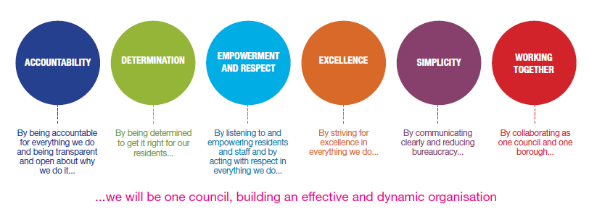
Job Description

Job Title: | Advanced Social Work Practitioner (Level 2)
Grade/Salary: | 12
Reports to: | Team Manager
Post Number: | Click or tap here to enter text.

Role Purpose:
The purpose of this role is to ensure high quality and effective social work practice in Dudley. You will lead and develop the professional practice of team members and other colleagues, and model and facilitate restorative practice. To promote and contribute to the strategic developments for children and their families in Dudley.
Advanced Social Work Practitioners (Level 2) will hold a caseload of extremely varied and highly complex and highly challenging and demanding cases and will play a key role in supporting best practice development, through sharing expertise and providing support and development for other practitioners. You will use your significant social work expertise and a clear child focus to secure the very best for our children, young people, and families.

Specific Responsibilities:

EXPERIENCE:
It is essential that the post holder has:

- Significant experience of working with children and young people in a statutory social care setting, including those in need of safeguarding and looked after and adopted children and young people.
- Demonstrable experience of leading practice and evidencing strong outcomes within safeguarding and child protection case work.
- Significant experience achieving results within a statutory social work role.
- Demonstrable experience of supporting others in a social work/social care role.
- Significant experience of supporting ASYE social workers, social work students in their development.
- Significant experience in making highly complex decisions relating to social service provision for children, young people and their families within Dudley.

KNOWLEDGE, SKILLS AND ABILITIES:
It is essential that the post holder has:
- Significant Knowledge and understanding of relevant legislative and regulatory framework and Government initiatives relating to children's services, including safeguarding, and the needs of looked after children and those placed for adoption.
- The tenacity to repeatedly meet service expectations regarding key performance indicators.
- Extremely High Emotional resilience, that is, the ability to perform effectively during periods of change.
- Willingness to enhance personal performance by seeking out constructive feedback, gaining insight and awareness of personal strengths and challenges.

ADDITIONAL INFORMATION
- To support the Team Manager in delivering high standards of practice and performance, established/statutory timescales.
- To intervene in areas of poor practice and lead by example to secure a lasting improvement in the service and individual performance.
- To promote and embed effective working models and practice within your respective team.
- To provide a level of group supervision to test the effectiveness of staff and their practice.
- To secure timely and effective intervention in complex cases by assisting non-qualified staff to deliver support to children and families.
- To meet statutory social work duties.
- To work collaboratively with partner agencies, within the children's directorate and in the voluntary sector to ensure multi-agency assessment, planning, intervention and review.
- To ensure that the Service seeks to involve parents/carers and young people in the planning of services and review processes, including actively seeking their views and their participation.

GENERIC ACCOUNTABILITIES:
- To maintain personal and professional development to meet the changing demands of the job, participate in appropriate training activities and encourage and support staff in their development and training.
- To undertake other such duties, training and/or hours of work as may be reasonably required and which are consistent with the general level of responsibility of this job.
- To undertake health and safety duties commensurate with the job and/or as detailed in the Directorate's Health and Safety Policy.
- The duties described in this job description must be carried out in a manner which promotes equality of opportunity, dignity and due respect for all employees and service users and is consistent with the Council's Equal Opportunities Policy.
- Working with some vulnerable children, young people and adults can, at times, be emotionally challenging for which appropriate support will be provided through management supervision. The post holder must be able to deal with such mental demands.
- This post is exempt from the Rehabilitation of Offenders Act and / previously met the definition of Regulated Activity (as defined by the Safeguarding Vulnerable Groups Act 2006) and is therefore subject to an enhanced Criminal Records Bureau (CRB) check (as defined by the Police Act).
- This post meets Regulated Activity (as defined by the Safeguarding Vulnerable Groups Act 2006 as amended by the Protection of Freedoms Act 2012) and is subject to an enhanced DBS check and the relevant children and/ adults barred list(s) checks.

KEY RESPONSIBILITIES:

- To be accountable for and promote equality, diversity and community cohesion to meet Group, Department and Function objectives. All employees have a responsibility not only for their own behaviour, but also for others regarding equality of opportunity. Any incident must be reported.

- To participate in a Performance Review and Development meeting and undertake a plan of training where necessary. Develop his/her own skills and expertise in a professional manner.

- In addition to all the responsibilities listed above, all employees must be flexible in their approach and undertake other duties that are commensurate with post holder’s level, wherever they may be, to achieve the objectives of the Group.

- To represent the Council and Group in a professional manner meeting the Corporate and Group aims. To comply with Group and Corporate policies.

- If appropriate to be responsible for the recruitment and performance management of designated teams and individuals in accordance with Corporate and Group aims and management style.

- To comply with the council’s financial regulation and standing orders

- To actively promote Dudley’s commitment to safeguarding and promoting the welfare of children, young people and vulnerable adults at a level appropriate to this group.

- Employees must comply with health and safety legislation and will be required to comply with the Council’s Health and Safety Policies. All employees must ensure that they take reasonable care of their own health and safety as well as the health and safety of any person that is affected by their actions.

- To be responsible for adhering to legislative requirements and Council Policies and Procedures including, but not exclusively health & safety, Data Protection and Internet/Email use.

SPECIAL CONDITIONS:

This post is subject to the DBS checking process (delete if not applicable)

Driving Licence will be subject to checking with the DVLA. It is a council requirement to have Business Use Car Insurance and a valid MOT certificate (For cars over 3 years old) (delete if not applicable)

The post holder is required to work onsite 3 days per week

Prepared by: | Click or tap here to enter text.
Date: | 31st March 2023

Essential criteria:
Person Specification
Experience |  | Application form | Technical assessment | Interview
 | Considerable experience within children's social care working with children and young people in a statutory social care setting including those in need of safeguarding and looked after and adopted children and young people.
 | Significant experience of achieving improved outcomes for children and young people.
 | Significant post qualifying experience.
 | Demonstrable experience in leading staff.
 | Demonstrable experience of successfully managing projects.
Qualifications / Training
 | A professional qualification in social work.
 | Social Work England registration.
Skills and abilities
 | Proven commitment to public service and the ability to champion equality, diversity and inclusion and embedding these as core values
 | Credibility in a significant area of specialism.
 | Ability to transfer skills and lead service improvement in a variety of areas of service.
 | The tenacity to repeatedly follow through indictors of service and staff performance to secure the necessary improvement in service provision.
 | Extremely high emotional resilience, that is, the ability to perform effectively during periods of change and stress and working with extremely varied and highly complex and highly challenging and demanding cases.
 | Highly developed negotiating and/or persuasive skills
Personal Qualities and Attributes
 | A knowledge of Equality & Diversity issues

