Business Support Officer



DMBC Operating Model 2024 - Vision:

A community-focused, financially resilient, collaborative, and sustainable council delivering the services required to support and meet the essential needs of residents, businesses, and the local economy.
Case for Change July 2024

Our Values:
Our values describe what we stand for and how we operate, and we expect our values to be lived and role-modelled throughout our organisation.

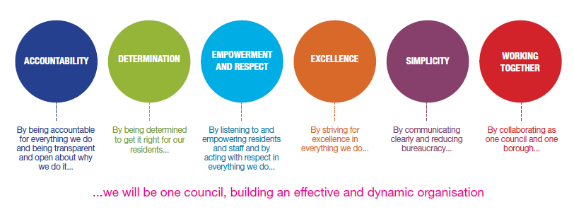
Job Description

Job Title: | Business Support Officer
Grade/Salary: | Grade 4 / £26,427.00 - £26,847.00
Reports to: | Business Improvement and Support Manager
Post Number: | AC3

Role Purpose:
Level 3 Staff work under the guidance of Supervisor/Manager with a limited degree of autonomy. Staff undertaking a level 3 role will need to have specific skills and experience and may carry out day-to-day responsibility for regular administrative tasks, overseen by Supervisor.
The basic entry requirement recommended for this role is NVQ 3 or equivalent. Staff should hold this qualification.

Specific Responsibilities:

- Transfer files electronically, including updating data, and preparing and sending files to other directorates through the secure web site
- Maintain more complex data and record systems, identifying and obtaining missing information where necessary
- Transfer files electronically, including updating data, and preparing and sending files to other directorates through the secure web site
- Administer administrative procedures
- Manage routine enquires from the general public
- Manage arrangements for publications and other publicity and or course /seminar materials,
- Undertake property related duties -- inventory recording and auditing, initiating repair and maintenance work etc.
- Draft replies to letters
- Ensure accident procedures followed and reports made
- Timesheets and other personnel records administration
- Attend meetings, take and prepare minutes.
- Collection of statistical information
- Awareness of Data Protection issues, including data protection administration as required.
- Using ICT packages to design and create high-quality material for formal publications and to support events e.g. Seminars, displays etc.
- Co-ordination, collation and submission of information and documentation relating to applications for grants and funding.
- To contribute to the planning, creation, development, implementation and operation of procedures and processes which allow effective liaison with external contractors.
- Prepare documentation where tasks require complete accuracy and confidentiality.
- Create, maintain and update confidential staff files.
- Supervision of work experience and trainees including basic instruction and answering of queries, under the direction of line supervisor/manager.
- Liaise with the relevant HR team as appropriate i.e. with respect to the recruitment process and/or providing basic advice and guidance on policies and procedures.
- Supporting recruiting managers with the recruitment of permanent employees and agency workers e.g. input of vacancies onto the recruitment system, planning and preparation for interviews, support on the day of interviews.
- Arrange temp / casual cover as required and process timesheets as necessary
- Cash handling as required - may include receipt, balancing and banking, Petty Cash reconciliation.
- Process payments and check invoices being signed off by Supervisor/Manager, ensuring that they are recorded on the appropriate system.
- Maintain records and registers of cash transactions.
- Prepare/initiate correspondence, collect and chase non payment of monies owed to Council.
- Be aware of and comply with divisional and directorate policies and procedures relating to health and safety, security, confidentiality, data protection, child protection and vulnerable adults. Reporting all concerns to the appropriate person.
- Contribute to the overall ethos/work/objectives of the division, directorate and council.
- Participate in training, other learning activities and performance development as required.
- Attend and participate in meetings as required.
- Any other duties commensurate with the duties/responsibilities/grade of the post.
- All staff will be expected to accept reasonable flexibility in working arrangements, and the allocation of duties including duties normally allocated to posts at a lower responsibility level, in pursuance of objectives of division, directorate and the Council, and effective team working.

Key Responsibilities:

- To be accountable for and promote equality, diversity and community cohesion to meet Group, Department and Function objectives. All employees have a responsibility not only for their own behaviour, but also for others regarding equality of opportunity. Any incident must be reported.
- To participate in a Performance Review and Development meeting and undertake a plan of training where necessary. Develop his/her own skills and expertise in a professional manner.
- In addition to all the responsibilities listed above, all employees must be flexible in their approach and undertake other duties that are commensurate with post holder’s level, wherever they may be, to achieve the objectives of the Group.
- To represent the Council and Group in a professional manner meeting the Corporate and Group aims. To comply with Group and Corporate policies.
- If appropriate to be responsible for the recruitment and performance management of designated teams and individuals in accordance with Corporate and Group aims and management style.
- To comply with the council’s financial regulation and standing orders
- To actively promote Dudley’s commitment to safeguarding and promoting the welfare of children, young people and vulnerable adults at a level appropriate to this group.
- Employees must comply with health and safety legislation and will be required to comply with the Council’s Health and Safety Policies. All employees must ensure that they take reasonable care of their own health and safety as well as the health and safety of any person that is affected by their actions.
- To be responsible for adhering to legislative requirements and Council Policies and Procedures including, but not exclusively health & safety, Data Protection and Internet/Email use.

Special Conditions:

This post is subject to the DBS checking process.

The post holder is required to work onsite 5 days per week. This is a non-hybrid role

Prepared by: | Jenny Steadman
Date: | 14 October 2026

Essential criteria:
Person Specification
Qualifications and Experience |  | Application form | Technical assessment | Interview
 | Demonstrable office experience including the development, management and operation of administrative systems. | √ |  | √
 | Demonstrable experience of financial record keeping, including processing of invoices, cash handling, and reconciliation. | √ |  | √
 | Demonstrable customer service experience including front-facing. | √ |  | √
 | NVQ level 3 in Business Administration or equivalent | √ |  | √
 | Willingness to participate in training and development opportunities | √ |  | √
Skills and abilities
 | Proven commitment to public service and the ability to champion equality, diversity and inclusion and embedding these as core values | √ |  | √
 | Able to communicate with a wide range of people with a clear understanding of customer care | √ |  | √
 | Able to demonstrate knowledge and use a range of ICT systems and solutions | √ |  | √
 | Demonstrate good numerical, verbal reasoning and literacy skills e.g by qualification | √
 | A Knowledge of Equality & Diversity issues | √ |  | √

