Environmental Health Officer / Senior Environmental Health Officer



DMBC Operating Model 2024 - Vision:

A community-focused, financially resilient, collaborative, and sustainable council delivering the services required to support and meet the essential needs of residents, businesses, and the local economy.
Case for Change July 2024

Our Values:
Our values describe what we stand for and how we operate, and we expect our values to be lived and role-modelled throughout our organisation.

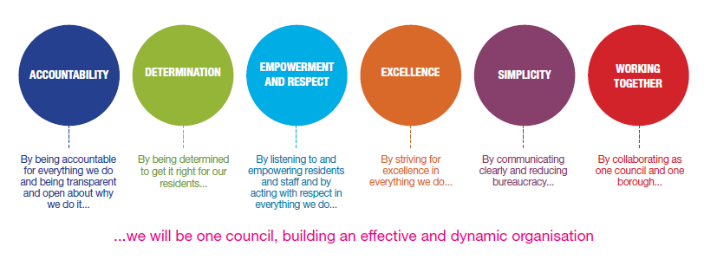
Job Description

Job Title: | Environmental Health Officer / Senior Environmental Health Officer
Grade and Salary: | 9 – 10 Depending on experience
Reports to: | Principal Environmental Health Officer
Post Number: | DUE215

Role Purpose:
The aim and objectives of the post are to conduct the full range of enforcement duties as required, by actioning all relevant legislation, and providing educative and administrating services associated with the work of the Section, primarily food safety and hygiene, food standards, health and safety inspection and smoke free compliance

Specific Responsibilities:
- Main duties of the post are fieldwork on site including appropriate visits, enforcement
activities and the relevant administration relating to the enforcement and educative activities.

- The inspection, surveying and assessment of premises, their processes, and practices relevant to the Section including specialist food safety, food standards and health and safety duties.

- The taking of emergency action under relevant food legislation including the service of legal Notices.

- Enforcement of the Health Act 2006 in relation to smoke free premises and vehicles and the issue of Fixed Penalty Notices and preparing reports for prosecution in line with the Enforcement Policy.

- Responding to complaints and enquiries relevant to the Section including infectious disease notifications.

- Undertaking all relevant duties associated with the work of exhumations.

- Advising the public, businesses and internal and external partners on specialist duties, enquiries and general issues of concern.

- Providing advice relevant to the work of the Section to all external and internal customers as directed by the Head of Environmental Health and Trading Standards or the Public Protection Manager (Environmental Health).

- Undertaking all relevant duties associated with the work of the Section.

- To be responsible for the safe custody of evidence, exhibits and court documents. To prepare statements, evidence for legal proceedings and prosecution reports and attend and give evidence in Court with regard to the full range of enforcement activities undertaken.

- To attend public meetings and to give talks or lectures on food safety matters as required. To be available outside normal hours as required.

- To assist in the training and development of staff (including colleagues and Student Environmental Health Practitioners) and external partners, e.g., Public Health trainees.

- To comply with the policies and procedures of the Environmental Health and Trading Standards department.

- Dealing with any other work which may be assigned by the Head of Environmental Health and Trading Standards or the Public Protection Manager (Environmental Health) from time to time.

- To be responsible for the safe custody and maintenance of technical equipment assigned to the postholder.

- To be responsible for safety matters associated with the implementation of work under the control of the post holder, as detailed within the Safety Policy.

Key Responsibilities:

- To be accountable for and promote equality, diversity and community cohesion to meet Group, Department and Function objectives. All employees have a responsibility not only for their own behaviour, but also for others regarding equality of opportunity. Any incident must be reported.

- To participate in a Performance Review and Development meeting and undertake a plan of training where necessary. Develop his/her own skills and expertise in a professional manner.

- In addition to all the responsibilities listed above, all employees must be flexible in their approach and undertake other duties that are commensurate with post holder’s level, wherever they may be, to achieve the objectives of the Group.

- To represent the Council and Group in a professional manner meeting the Corporate and Group aims. To comply with Group and Corporate policies.

- If appropriate to be responsible for the recruitment and performance management of designated teams and individuals in accordance with Corporate and Group aims and management style.

- To comply with the council’s financial regulation and standing orders

- To actively promote Dudley’s commitment to safeguarding and promoting the welfare of children, young people and vulnerable adults at a level appropriate to this group.

- Employees must comply with health and safety legislation and will be required to comply with the Council’s Health and Safety Policies. All employees must ensure that they take reasonable care of their own health and safety as well as the health and safety of any person that is affected by their actions.

- To be responsible for adhering to legislative requirements and Council Policies and Procedures including, but not exclusively health & safety, Data Protection and Internet/Email use.

Special Conditions:

This post is subject to the DBS checking process

Driving Licence will be subject to checking with the DVLA. It is a council requirement to have Business Use Car Insurance and a valid MOT certificate (For cars over 3 years old)

The post holder is required to work onsite 3 days per week

Prepared by: | Lucy Tromans
Date: | Jan 26

Essential criteria:
Person Specification
Qualifications and Experience |  | Application form | Technical assessment | Interview
 | Postholder will be required to have an appropriate professional qualification in the field of environmental health | x |  | x
 | Qualified Officer having passed the final year examinations and having acquired a Certificate of Registration of the Environmental Health Officers Registration Board or equivalent for the inspection of food premises. | x |  | x
Skills and abilities
 | Proven commitment to public service and the ability to champion equality, diversity and inclusion and embedding these as core values | x |  | x
 | Good communication skills, both written and verbal. | x |  | x
 | An ability to organise your own workload and prioritise effectively. | x |  | x
 | Computer literate. | x |  | x
 | A thorough and up to date knowledge of relevant legislation and technical and professional expertise are necessary for the performance of the duties of the Service in which they are engaged. | x |  | x
 | A flexible approach to work issues and responsibilities. | x |  | x
 | Be able to deal effectively with pressure in difficult situations. | x |  | x
 | The ability to work within a team and maintain a team approach to performance of the duties. | x |  | x
 | To be able to maintain a customer orientated approach to the performance of duties and maintain a competent level of knowledge and skills. | x |  | x
 | A willingness to develop as an individual and as a professional officer and to attend appropriate training courses as identified during the Council’s employee appraisal meetings, ‘Our Dudley Conversations’. | x |  | x
 | To be able to deal with confrontational situations. | x |  | x
 | The possession of a full and clean driving licence. | x |  | x

