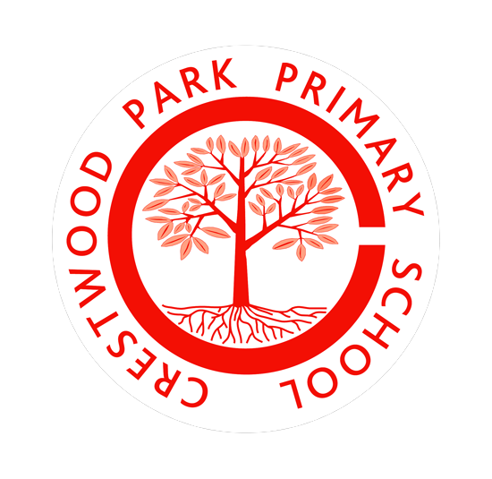

Crestwood Park Primary School

Vacancy for a Class Teacher

(Key Stage to be determined)

This is a temporary post for maternity cover

Main Scale M1-M4
ECT’s welcome to apply

We require, from September 2025, a motivated and enthusiastic teacher to join our hard working and dedicated team of staff.

We are a welcoming school with a family ethos. We pride ourselves on our nurturing and supportive environment for all members of our school community.

The successful candidate will have the highest expectations of pupils academically, behaviourally and socially and through their engaging practice aid pupils to…

“Be the best that you can be.”

Please apply via the online portal as only online applications are acceptable. Please contact the school Business Manager, Mrs. Hughes to arrange contact with the school. Please note that we consider personal contact with our school prior to application as essential.

Closing date: Monday 28th April
Interviews: Wednesday 7th May (times to be confirmed)

For further details, please read the person specification and job description.

Crestwood Park Primary School is committed to Safeguarding and promoting the welfare of its pupils and vulnerable adults and expect all staff and volunteers to share this commitment. We follow the Safer Recruitment practice, and the successful candidate will be required to undertake an Enhanced Disclosure from the DBS (Disclosing and Barring Service).

Crestwood Park Primary School
Phone 01384 818315
Email info@crestwood-p.dudley.sch.uk
Website https://crestwoodpark.sch.life
Headteacher – Mrs Liz Kennedy

