Outreach Worker

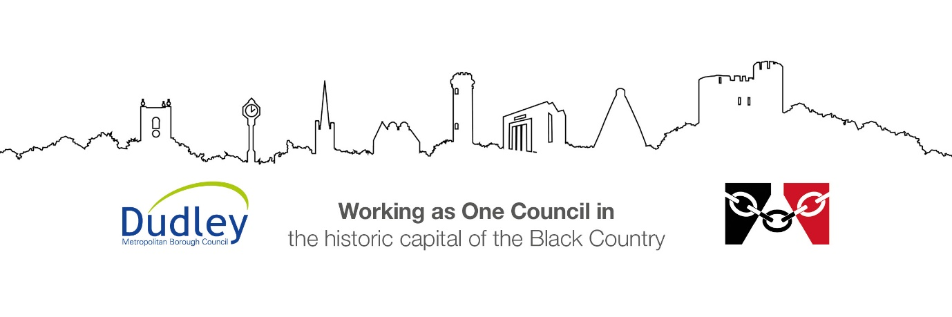

DMBC Operating Model 2024 - Vision:

A community-focused, financially resilient, collaborative, and sustainable council delivering the services required to support and meet the essential needs of residents, businesses, and the local economy.
Case for Change July 2024

Our Values:
Our values describe what we stand for and how we operate, and we expect our values to be lived and role-modelled throughout our organisation.

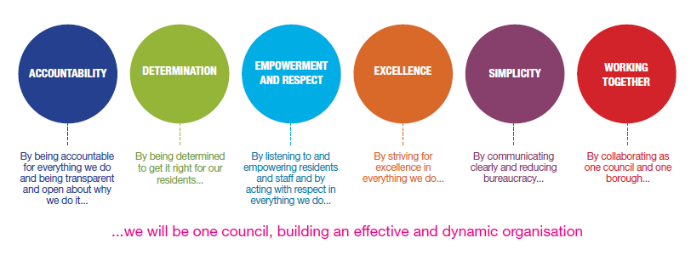
Job Description

Job Title: | Outreach Worker
Grade and Salary: | Grade 7 - £31,537 - £34,434
Reports to: | Area Community Learning Manager
Post Number: | DAC376

Role Purpose:
- To undertake outreach work and the delivery of learning/employability programmes in the Dudley area within the Adult and Community Learning Team

- To engage adults and families in learning that supports their individual learning needs, personal development and increases their opportunities to gain qualifications, skills and employment.

- To undertake needs analysis of local communities and individuals, working in partnership with other learning providers, partners and stakeholders.

Specific Responsibilities:

- To undertake the proactive recruitment and engagement of the local community into appropriate learning and employability opportunities.
- Undertake delivery of information, advice and guidance work to adults ensuring referral to appropriate support services as required.
- Undertake partnership working with employment services and other relevant agencies to ensure vacancy awareness and workforce development needs are known and shared
- Engage in appropriate capacity building of community and voluntary groups within the locality.
- Undertake a needs analysis of local communities working with other partners and providers.
- Liaise with designated FE Colleges within the Joint Working Partnership to ensure learners access appropriate courses in community settings and the provision of appropriate tutors.
- Gain appropriate learner feedback in order to monitor and improve the quality of provision.
- Support learners to ensure that personal learning/employment goals are achieved
- Tracking individuals progression as appropriate ensuring Quality and compliance measures are met.
- Ensure that all Management Information including enrolment, retention, attendance and achievement recording of all learners is collated and available in respect of contract requirements, inspections and all performance management targets and that appropriate income claims are completed on time.
- Work with the ACL team and partners to agree targets and service delivery to meet identified local needs.
- Engage in relevant marketing activities to ensure that the work of the ACL team is well known within the local area.
- Advise managers of potential development opportunities to ensure that the service remains responsive and proactive to the needs of local residents
- Work with partners from relevant services and agencies to ensure service delivery is effective and co-operative, value for money and does not duplicate or compete with other provision within the areas.
- Participate in supervision processes in support of personal development and ensure that relevant staff development needs are shared with Line Management.
- Undertake training as appropriate to meet any changes in standards or appropriate legal requirements as required.
- Able to be flexible to work daytimes, evenings and weekends as required.

Key Responsibilities:

- To be accountable for and promote equality, diversity and community cohesion to meet Group, Department and Function objectives. All employees have a responsibility not only for their own behaviour, but also for others regarding equality of opportunity. Any incident must be reported.

- To participate in a Performance Review and Development meeting and undertake a plan of training where necessary. Develop his/her own skills and expertise in a professional manner.

- In addition to all the responsibilities listed above, all employees must be flexible in their approach and undertake other duties that are commensurate with post holder’s level, wherever they may be, to achieve the objectives of the Group.

- To represent the Council and Group in a professional manner meeting the Corporate and Group aims. To comply with Group and Corporate policies.

- If appropriate to be responsible for the recruitment and performance management of designated teams and individuals in accordance with Corporate and Group aims and management style.

- To comply with the council’s financial regulation and standing orders

- To actively promote Dudley’s commitment to safeguarding and promoting the welfare of children, young people and vulnerable adults at a level appropriate to this group.

- Employees must comply with health and safety legislation and will be required to comply with the Council’s Health and Safety Policies. All employees must ensure that they take reasonable care of their own health and safety as well as the health and safety of any person that is affected by their actions.

- To be responsible for adhering to legislative requirements and Council Policies and Procedures including, but not exclusively health & safety, Data Protection and Internet/Email use.

Special Conditions:

This post is subject to the DBS checking process

Driving Licence will be subject to checking with the DVLA. It is a council requirement to have Business Use Car Insurance and a valid MOT certificate (For cars over 3 years old)

The post holder is required to work onsite 3 days per week

Prepared by: | Rizwana Hussain
Date: | August 2026

Essential criteria:
Person Specification
Qualifications and Experience |  | Application form | Technical assessment | Interview
 | Experience of working within an Adult learning/employability environment is essential
 | Working with diverse groups
 | Working to quality standards for learning
 | Team working and collaboration
 | Meeting deadlines and achieving performance targets
 | Partnership working with diverse groups and organisations including employers and stakeholders
 | Collecting data and qualitative information to support Contract Management
 | Capacity building with communities and neighbourhoods
 | Information, Advice and Guidance Work with Adults
 | Assuring Health and Safety standards are adhered to
 | Minimum full level 2 qualifications: (5 GCSEs A-C or equivalent) including literacy and numeracy
 | In receipt of or willing to work towards NVQ level 3 in Advice and Guidance Work
 | Proficiency in using Microsoft packages, including Word and Excel.
Skills and abilities
 | Proven commitment to public service and the ability to champion equality, diversity and inclusion and embedding these as core values
 | Clear verbal and written communication skills
 | IT literate
 | Ability to analyse statistical information and write reports.
 | Ability to support individuals to identify and achieve targets and goals.
 | Able to plan and manage their workload.
 | Solution focused
 | Good organisational skills.
 | Flexible approach to working
 | Confident communicator
 | Good team worker

