Senior Family Time Worker

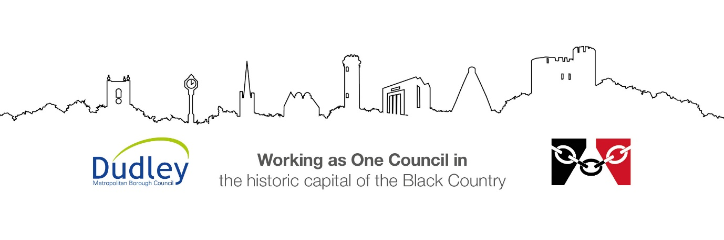

DMBC Operating Model 2024 - Vision:

A community-focused, financially resilient, collaborative, and sustainable council delivering the services required to support and meet the essential needs of residents, businesses, and the local economy.
Case for Change July 2024

Our Values:
Our values describe what we stand for and how we operate, and we expect our values to be lived and role-modelled throughout our organisation.

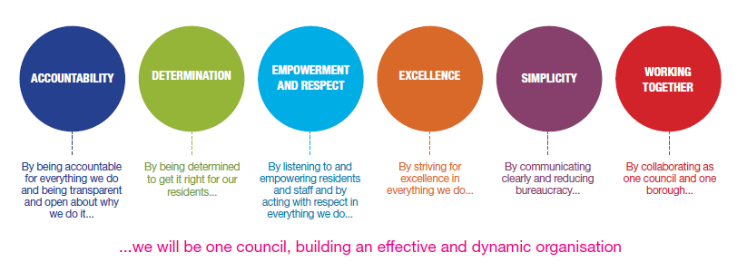
Job Description

Job Title: | Senior Family Time Worker
Grade/Salary: | 8
Reports to: | Team Manager- Family Time
Post Number: | Click or tap here to enter text.

Role Purpose:
To be responsible for a Family Time Service providing quaility in-house supverised family time sessions by arranging/planning supervised sessions, working in partnership with families and other professionals.
Working closely with the social work area teams, any court team and the fostering service.The Family Time Service is responsible for instituting high quality Family Time sessions for vulnerable children and young people with their families and carers.
The Senior Family Time worker will be responsible for overseeing the day-to-day activities of the Family Time Service and supervising a team of Family Time workers.
Excellent customer service and communication skills are an essential requirement of this job. The candidate will need to be a confident and assertive individual capable of making decisions and problem solving. The successful candidate will be able to demonstrate sound judgement and an excellent knowledge of the relevant legislation and safeguarding practices.
The post will ensure that Family Time sessions are robustly planned for and managed and ensure that all sessions are recorded effectively onto the local authority’s system. Further to this, that data can be drawn effectively from records and used to inform needs analysis and training needs within the directorate.
The successful candidate will be accountable for ensuring the team achieves its operational plan by promoting an appropriate restorative working culture, empowering others and setting and maintaining high and measurable standards of practice.

Specific Responsibilities:

- Manage the internal referral process into the Family Time Service.
- Create the conditions within the Family Time Centres to ensure a child-focused approach.
- Advise staff on safeguarding matters and take appropriate action, where escalations are necessary, keeping the Team Manager and Service Manager informed.
- Support the Team Manager and Service Manager in gaining information for reports as required by the local authority.
- Maintain case notes and files in line with DMBC file policy.
- Comply with DMBC policies, procedures and in particular Safeguarding,
- Health & Safety, and GDPR Policies to protect the health, safety and welfare of yourself and others.
- Work flexibly as required by the service, including covering Family Time support sessions (as required), and take part in meetings in order to support effective service delivery.
- Complete monitoring, auditing, and observations of direct practice to improve quality and standards, and to support in understanding the training needs of the team.
- Ensure the Family Time Centres’ day to day running is effective and efficient, and to ensure all building maintenance issues are reported to the Team Manager.
- Develop effective relationships with staff within the local authority such as social workers, foster carers and managers.
Management of Staff and the Service Needs
- To provide effective line management to family time workers, including their training and development, supervision, and appraisals.
- To lead on to team planning including the co-ordination and prioritisation of the team’s workload considering level of risk, needs and frequency.
- Participate in and contribute to training programmes to increase knowledge, understanding and skills, making full use of local authority training opportunities.
- Take responsibility for identifying personal and professional training needs and undertake training as agreed with the Team Manager.
- Maintain a high standard of professional practice both within DMBC, and in the wider multi- agency environment, including keeping up to date with standards of good practice and local developments for service provision.

Key Responsibilities:

- To be accountable for and promote equality, diversity and community cohesion to meet Group, Department and Function objectives. All employees have a responsibility not only for their own behaviour, but also for others regarding equality of opportunity. Any incident must be reported.

- To participate in a Performance Review and Development meeting and undertake a plan of training where necessary. Develop his/her own skills and expertise in a professional manner.

- In addition to all the responsibilities listed above, all employees must be flexible in their approach and undertake other duties that are commensurate with post holder’s level, wherever they may be, to achieve the objectives of the Group.

- To represent the Council and Group in a professional manner meeting the Corporate and Group aims. To comply with Group and Corporate policies.

- If appropriate to be responsible for the recruitment and performance management of designated teams and individuals in accordance with Corporate and Group aims and management style.

- To comply with the council’s financial regulation and standing orders

- To actively promote Dudley’s commitment to safeguarding and promoting the welfare of children, young people and vulnerable adults at a level appropriate to this group.

- Employees must comply with health and safety legislation and will be required to comply with the Council’s Health and Safety Policies. All employees must ensure that they take reasonable care of their own health and safety as well as the health and safety of any person that is affected by their actions.

- To be responsible for adhering to legislative requirements and Council Policies and Procedures including, but not exclusively health & safety, Data Protection and Internet/Email use.

Special Conditions:

This post is subject to the DBS checking process (delete if not applicable)

Driving Licence will be subject to checking with the DVLA. It is a council requirement to have Business Use Car Insurance and a valid MOT certificate (For cars over 3 years old) (delete if not applicable)

The post holder is required to work onsite 3 days per week

Prepared by: | Maxine Brown
Date: | 20th July 2026

Essential criteria:
Person Specification
Qualifications and Experience |  | Application form | Technical assessment | Interview
 | Knowledge of Children’s Services, Children Looked After and Safeguarding. | √ |  | √
 | Experience of working with children, either in the public or private sector, with an understanding of the impact of trauma and measures to support | √ |  | √
 | Experience of supervising staff | √ |  | √
 | GCSE Level A0C in English and Maths | √
 | Experience of representing a team at inter-agency meetings | √ |  | √
 | Experience of managing a workload effectively, maintaining appropriate records, preparing and submitting reports as required | √ |  | √
 | Enhanced DBS | √
 | Computer Literate with the ability to operate IT and camera equipment | √
 | Experience of managing a building, ensuring application and adherence to Health and Safety for self and others | √ |  | √
Skills and abilities
 | Proven commitment to public service and the ability to champion equality, diversity and inclusion and embedding these as core values | √ |  | √
 | Good communication skills (oral and written), with the ability to communicate with children, young people, parents, carers and staff | √ |  | √
 | Ability to contribute to the creation and maintenance of good working relationships with colleagues at different levels, partner agencies, local community groups and other city council departments | √ | √ | √
 | Ability to work as an individual and as part of a team | √ |  | √
 | Able to fulfil the travel requirements of the role | √
 | Ability to understand, analyse and distil a clear message from complex information | √
 | Ability to think creatively | √

