Senior Families First Partnership Officer

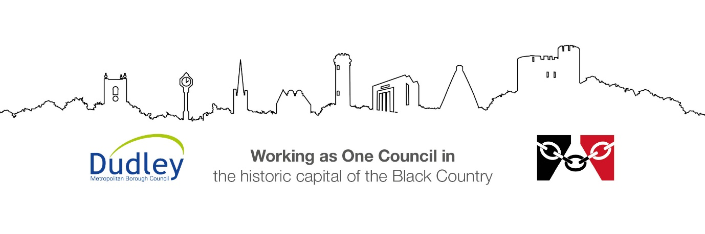

DMBC Operating Model 2024 - Vision:

A community-focused, financially resilient, collaborative, and sustainable council delivering the services required to support and meet the essential needs of residents, businesses, and the local economy.
Case for Change July 2024

Our Values:
Our values describe what we stand for and how we operate, and we expect our values to be lived and role-modelled throughout our organisation.

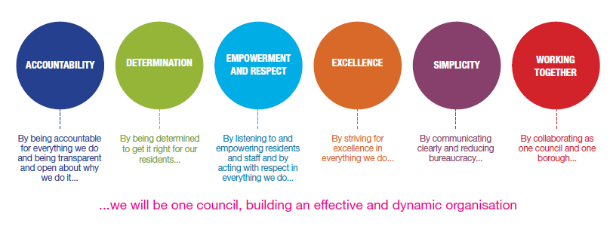
Job Description

Job Title: | Senior Families First Partnership Officer
Grade/Salary: | 10 £42,838 - £46,142
Reports to: | Service Manager – Family Hubs
Post Number: | PS184

Role Purpose:
The primary purpose of the post is to work as an effective team leader positively implementing the Early Help strategy, prioritising the needs of complex families often with multiple interrelated problems. This position is fundamental in coordinating the work of a team of Families First Partnership Officers and on a day to day basis will require the post holder to:
- Support the management of the day-to-day delivery of an effective, well performing team in an effort to improve outcomes for children and young people.
- Provide support and advice to team members and lead on professional development
- Provide reflective supervisions both in a group and on a one-to-one basis
- Undertake staff observations and provide constructive feedback to staff members
- Lead and co-ordinate high quality evidence based single assessments, develop and implement high quality Family Support plans to secure the best outcomes for children and young people.
- Work closely with partners to support and enable professionals to complete good quality Single Assessments.
- Proactively support professionals to carry out the Lead Professional role. Ensuring professionals feel confident to chair team around the child/family meetings.
- Model best practice in working in partnership with families to ensure that they are provided with the right support at the right time
- Actively support and help staff the Early Help Desk within the MASH.
- Deliver a ‘Think Family’ approach ensuring that all services working with the family are coordinated and work effectively together whilst maintaining a focus upon the safety and wellbeing of the children and young people.
- Have a well developed understanding of the thresholds and to spread this knowledge and understanding across the partnership. To ensure children and young people are receiving the right support at the right time.
- Ensure we have robust systems in place and advocate the voice of the child in all meetings and direct work with children, young people and their families.
- Demonstrate how to work assertively with families with the most complex often interrelated problems including reducing truancy and school exclusion, improving under attainment and aspiration through education learning and employment
- Ensure that all children, young people and vulnerable adults are adequately protected in line with Dudley Safeguarding Children and Adult Board reporting procedures

Specific Responsibilities:
Key Accountabilities | Expected Outcomes
Maintains consistent management oversight in the response to contacts, notifications and requests and is able to make timely decisions to avoid drift or delay ensuring that children are protected and their welfare promoted. | Children in Dudley are safer as a result of Early Help support being provided at the right time when it is most needed
Direct line management responsibility for operational staff including, supervision, performance development and day to day operational duties. | Staff feel supported and valued
Line Management of family support in an effort to promote better outcomes for children, young people and their families. | Staff feel empowered to deliver quality services and feel supported to make decisions and take action as and when appropriate
Support Service Manager to positively promote and publicise Early Help Services across the whole partnership. | Service Manager will have reassurance that the Early Help offer in Dudley is continually promoted and utilised across the partnership
Provides oversight for the day to day running of the Partnership Officer team (by leading, coaching and mentoring staff) to work in partnership with families. | - Team deliver high quality services and meet pre-set performance targets.  - Team members behave professionally.  - Team performance is driven by needs of the service.
Undertake staff observations, quality assure and audit assessments, reports and plans | - Observations for staff happen regularly and constructive feedback is provided thus improving practice  - Assessments and reports are of good quality
Maintains regular supervision through frequent meetings and briefings in line with the Department’s supervision policy. Contribute to the development of other workers sharing knowledge and skills as appropriate. | - Receives and participates in supervision in accordance with agreed policy and practice.  - Shares knowledge and skills with colleagues as appropriate.  - Uses supervision to reflect and analyse cases and develop professional practice.
Ensures that expenditure on cases is properly authorised and recorded, in accordance with departmental procedures. | - Expenditure is appropriately authorised and recorded in line with audit guidance
Undertake an enabling role to support other professionals working within Prevention/Early Help Services when required. | - The team is responsive to planned and unplanned service requirements.  - The team functions effectively to prioritise and meet the needs of children, young people and their families, family life is improved.  - The team are able to evidence good quality Early Help Assessments.  - Professionals feel comfortable to chair and participate in Team around the Child/Family meetings.
As a team member provide and participate effectively in supervision, training, team meetings, mentoring and coaching activities as directed by the Service Manager | - Children, young people and their families living within the community receive high quality evidence based intervention.  - Intervention with families is based upon a professional relationship to facilitate partnership, resilience and change, is evidence based, objective, respectful and assertive.  - Family support workers are able to model good practice
Provide and inspire innovative ways to engage with families in their own homes or out in the community to build on their own skills and knowledge through a variety of activities and intervention. Sharing good practice across Early Help Services. | - Families with complex and interrelated problems and a history of non engagement, disengagement, non-compliance or disguised compliance are enabled to develop positive behaviours and strategies, become strengthened and resilient and reduce need for specialist services.  - Family support workers are able to develop their skills and knowledge.
Establish positive relationships with all partners both within Early Help, Statutory Services and the wider partnership. Enabling and facilitating positive and effective step down from Statutory intervention to early help. | - Plans and intervention are appropriate to assessed need, improvement goals are specific, measureable, achievable, realistic and timely and agreed by family members.  - Professionals understand when to apply the right thresholds.  - All professionals understand the Early Help Offer.  - Families First Partnership Officers develop good practice across the Partnership.
When required, support and staff the Early Help Desk within the MASH. | - Reduce the waiting times for families needing early help services  - Professionals are confident in completing early help assessments at the right time  - Outcomes for children and young people are improved.  - The risk of abuse and neglect for children and young people living within the family is reduced  - Families First Partnership Officers support other workers to develop skills and strategies to engage with ‘hard to engage’ families.
Lead, carry out and audit high quality evidence based Early Help assessments and develop and implement high quality Early Help Family Support plans | - Early Help Assessments, family support plans and reviews are evidence based, accurate, of a high standard and up-to-date.  - Early Help Assessments, family support plans and reviews are quality assured and are of a good standard.  - Family support workers develop good practice
Enable the development of positive strategies to enable families to gain and maintain independence and control over all aspects of their lives and contribute positively within the community | - Families become resilient as they develop and implement skills and strategies, in doing so they regain control and independence and the need for specialist intervention and services is reduced.  - Family support workers develop a range of skills and strategies when working with complex families.
Support the development of others, modelling good practice in the leadership and delivery of protective or supportive interventions for children and young people with needs assessed at targeted and specialist level and reduce the risk of abuse and neglect. | - Ensure that records are accurate and timely, in line with recording procedures  - Work alongside social workers to implement the Care plan when specialist intervention is required  - Ensure that the allocated social worker is updated on the general progress of the family as appropriate.  - Work with families to maintain children in their families where it is safe to do so and delivers preventative interventions.  - Improve outcomes for children.  - Family support workers develop a range of skills and strategies when working with complex families where children and young people are at risk of abuse or neglect
Encourage and enable Family Support plans to be reviewed to determine progress against identified outcomes ensuring that the child’s welfare is paramount throughout. | - Demonstrate sound judgement regarding the needs of children and young people.  - Plans are implemented, monitored and reviewed to improve outcomes for the child.  - Plans are quality assured and are of a good standard.  - Analysis is effective in identifying risk and need.  - Whilst adopting a ‘Think Family’ approach it is important to retain a focus upon the safety and welfare of the children and young people in line with legislation, and DSCB procedures.  - Family support workers are able to model good practice
Identify and report gaps in Early Help Services in an effort to design and implement innovative solutions to the filling these gaps | - The Early Help is robust and is able to support families from reaching crisis.
Ensure that personal and team records are up to date, of a high quality and submitted according to appropriate timescales. | - Records are accurate, up-to-date and produced within agreed timescales.  - Written English is of a high standard.  - Early Help Enablers are able to develop their skills and model good practice
Write good quality reports detailing the work undertaken with the family as required by the service area and can include Court Statements. | - Reports are of good quality, are factually accurate and balanced, are written to a good standard of English  - Family support workers are able to develop their skills and model good practice
Work co-operatively with colleagues and in partnership across agency boundaries. | - Effective partnership working is in place, producing high quality multi-agency plans to improve outcomes for children, young people and their families.  - Family support workers are able to develop their skills and model good practice
Attends a range of meetings including child protection case conference meetings, Step Down to Child in Need, Locality and Early Help Meetings. | - Provides factual balanced information to meetings in a professional manner  - Family support workers are able to develop their skills and model good practice
Leads Early Help meetings when required to develop others by modelling best practice | - Leads the Early Help meeting to enable family members and professionals to share information, accurately in a balanced and respectful manner.  - Facilitate the meeting to identify strengths and concerns.  - Enable the family to set achievable goals and goals for improvement with progress indicators and timescales.  - Review progress  - Record the notes from the meeting and construct the Family Support plan.  - Arrange the review meeting ensuring that the date, time and location is agreeable to the family and takes account of family routines and pressures.  - Family support workers are able to develop their skills and model good practice
Engage with families in an assertive but supportive manner, enabling families to in identify the concerns / problems and the solutions. | - Family support service intervention is of high quality  - All family members fully participate in the decisions that affect them and develop family support plans.  - Direct work undertaken with children and their families in accordance with agreed care plans to improve outcomes for children.  - The wishes and feelings of children and young people are ascertained, recorded accurately and taken account of in Family Support plans and reviews.  - Family support workers are able to develop their skills and model good practice
Undertake planned and unplanned community based visits, including working within the families own home during weekdays, evenings, weekends and bank holidays on a rota basis to monitor and assess progress in engaging with, and achieving the agreed objectives within the ‘Plan’ | - Families are supported to sustain improvement outside of office hours  - Assessments capture information across the daily timetable of routines  - Families are strengthened, they develop resilience and strategies to meet children and young people’s needs and children and young people thrive  - Changes in levels of risk and vulnerability are identified early to enable protective safeguarding activity to be undertaken.  - Family support workers are able to develop their skills and model good practice
Carries out all work within equal opportunities and anti-discriminatory frameworks. | - Recognises and values diversity and is sensitive to cultural difference.  - Adheres to Dudley’s Values and Behaviours Framework.  - Family support workers are able to develop their skills and model good practice
Carries out statutory obligations in accordance with departmental policy and practice. | - Statutory obligations of the role are understood and complied with at all times.  - Family support workers are able to develop their skills and model good practice
Keeps up-to-date with and acts in accordance with current legislation and departmental practice and initiatives, ensuring | - Accurately interprets and applies relevant policies procedures and initiatives.  - Applies relevant policies to practice.  - Family support workers are able to develop their skills and model good practice
Develops/maintains good working relationships with other professionals in all agencies. | - Positive working relationships are fostered and maintained  - Effective partnership working and sharing of information.
Maintains accurate, up to date, and relevant case recordings and any other records as specified in departmental guidance and procedures’ and utilising tools such as the electronic Case Management system as appropriate. | - Accurate case records are in place in relation to own cases.  - Systems are utilised and maintained.  - Data is recorded timely and accurately.  - Family support workers are able to develop their skills and model good standards
Maintains regular supervision through frequent attendance at meetings and briefings in line with the Department’s supervision policy. Contribute to the development of other workers sharing knowledge and skills as appropriate. | - Receives and participates in supervision in accordance with agreed policy and practice.  - Shares knowledge and skills with colleagues as appropriate.  - Uses supervision to reflect and analyse cases and develop professional practice.
Reports changes to risk levels, care plans or children’s circumstances to their supervisor on a regular basis or immediately as required. Seeks advice on appropriate action, developing new risk assessments and care plans as guided by their supervisor | - Exercises effective judgement when assessing risk and seeks advice as appropriate to safeguard the welfare of children.  - Alerts line manager and allocated social worker (or EDT if out of hours) to emerging escalating risks and concerns regarding children and young people’s safety and welfare on the same working day.  - Children and young people are safeguarded.
Contributes through team meetings and organisational events to the development of the service. | - Makes a positive contribution to team meetings and events.
Maintains and develops up-to-date knowledge and relevant skills through continued learning. | - Undertakes learning and development opportunities as available, completing courses as advised by your supervisor.
Ensures that expenditure on cases is properly authorised and recorded, in accordance with departmental procedures. | - Expenditure is appropriately authorised and recorded.

Key Responsibilities:

- To be accountable for and promote equality, diversity and community cohesion to meet Group, Department and Function objectives. All employees have a responsibility not only for their own behaviour, but also for others regarding equality of opportunity. Any incident must be reported.

- To participate in a Performance Review and Development meeting and undertake a plan of training where necessary. Develop his/her own skills and expertise in a professional manner.

- In addition to all the responsibilities listed above, all employees must be flexible in their approach and undertake other duties that are commensurate with post holder’s level, wherever they may be, to achieve the objectives of the Group.

- To represent the Council and Group in a professional manner meeting the Corporate and Group aims. To comply with Group and Corporate policies.

- If appropriate to be responsible for the recruitment and performance management of designated teams and individuals in accordance with Corporate and Group aims and management style.

- To comply with the council’s financial regulation and standing orders

- To actively promote Dudley’s commitment to safeguarding and promoting the welfare of children, young people and vulnerable adults at a level appropriate to this group.

- Employees must comply with health and safety legislation and will be required to comply with the Council’s Health and Safety Policies. All employees must ensure that they take reasonable care of their own health and safety as well as the health and safety of any person that is affected by their actions.

- To be responsible for adhering to legislative requirements and Council Policies and Procedures including, but not exclusively health & safety, Data Protection and Internet/Email use.

Special Conditions:

This post is subject to the DBS checking process (delete if not applicable)

Driving Licence will be subject to checking with the DVLA. It is a council requirement to have Business Use Car Insurance and a valid MOT certificate (For cars over 3 years old) (delete if not applicable)

The post holder is required to work onsite 3 days per week

Prepared by: | Cornelia Heaney
Date: | January 2026

Essential criteria:
Person Specification
Qualifications and Experience |  | Application form | Technical assessment | Interview
 | Professional qualification relevant to work with children, young people and families at NVQ3 or above. | √
 | Literacy and English writing and numeracy skills level 3 and above | √ | √
 | Evidence of continued learning and development | √
 | Good level of IT skills and application | √ |  | √
 | Substantial experience of working with children, young people and families at risk of specialist intervention. | √ |  | √
 | Substantial experience) of working with families with multiple and complex interrelated problems. This experience must also include co-ordinating and leading on cases. | √ | √ | √
 | Substantial experience of delivery of evidence based parenting programmes or interventions or a willingness to undertake training to deliver these. | √ |  | √
 | Substantial experience of carrying out risk and needs assessment and the development, coordination, implementation, monitoring and review of Family support plans | √ | √ | √
 | Substantial experience of working in a multi-agency setting/environment. | √ |  | √
 | Knowledge of the Authority’s relevant procedures or practices plus additional professional knowledge around the Early Help Strategy | √ |  | √
 | Experience in the supervision and management of employees, or other people in an equivalent position. | √ |  | √
Skills and abilities
 | Proven commitment to public service and the ability to champion equality, diversity and inclusion and embedding these as core values | √ |  | √
 | Skills in assessment, critical analysis and decision-making | √ | √ | √
 | Excellent ability to work in partnership with children and families and a wide range of agencies. | √ |  | √
 | Excellent ability to keep accurate and up to date records. | √ |  | √
 | Excellent ability to effectively engage and sustain relationships with children, young people and their families |  |  | √
 | Excellent ability to communicate effectively with children, young people and their families |  | √
 | Excellent ability to communicate effectively orally and in writing, and to produce a variety of information to aid decision making | √ |  | √
 | Excellent ability to work effectively and as part of a team |  |  | √
 | Excellent knowledge of child development and the needs of children and young people | √ |  | √
 | Proven ability to lead and co-ordinate child centred meetings |  |  | √
 | Ability to develop solutions or plans for future implementation, up to a year ahead in line with the regular review of the Early Help Strategy | √ |  | √
 | Ability to work independently and exercise discretion and initiative over a broad area of activity | √ |  | √

