Senior Business Support Officer

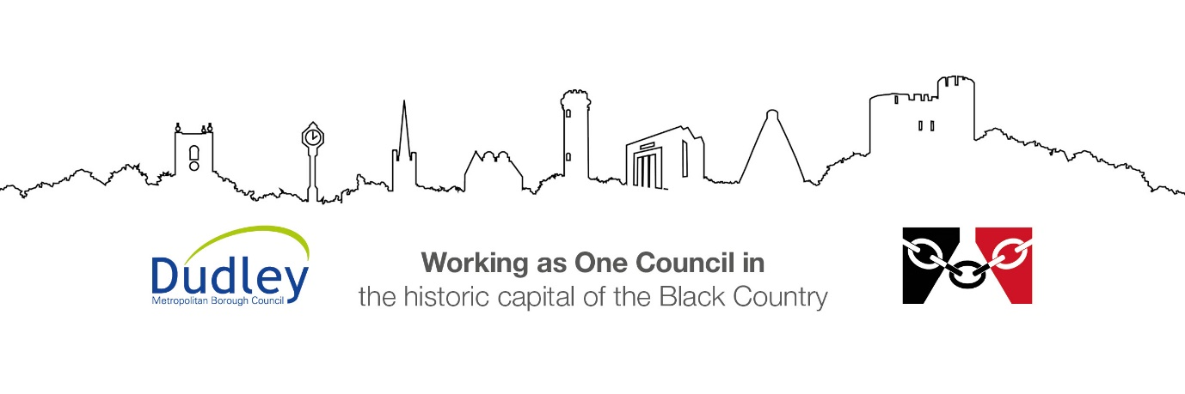

DMBC Operating Model 2024 - Vision:

A community-focused, financially resilient, collaborative, and sustainable council delivering the services required to support and meet the essential needs of residents, businesses, and the local economy.
Case for Change July 2024

Our Values:
Our values describe what we stand for and how we operate, and we expect our values to be lived and role-modelled throughout our organisation.

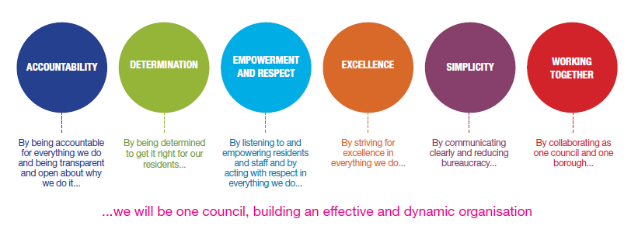
Job Description

Job Title: | Senior Business Support Officer
Grade/Salary: | 5 / £27,274 - £29,071
Reports to: | Education Travel Support Manager
Post Number: | AC4

Role Purpose:
Level 4 Staff will work with a reasonable degree of autonomy and may be responsible for a number of areas of work. Staff working at level 4 may also be responsible for the supervision of other staff members.

Staff undertaking a level 4 role must have specific skills and experience relative to the role being undertaken and will carry responsibility for overseeing tasks with only occasional referral to line manager. The entry requirement recommended for this role is NVQ Level 3.

Specific Responsibilities:

- To be able to organise and attend Stage 2 appeal meetings to capture minutes.
- Communicating Stage 2 Appeals outcomes to parents / carers.
- Financial admin of invoices, payments and setting up purchase orders.
- Processing of orders and identification of budget codes
- General administration within the team.
- Support with managing incoming calls and emails
- To contribute to the arrangement of meetings and other events including the arrangement for attendance, the booking of equipment, services and rooms.
- Support general and routine enquiries from members such as parent’s carers, contractors and partner agencies.
- Ensure data entry across key systems are updated.
- Co-ordinating the content for publications and liaising with external publishers as necessary
- Preparation of orders and identification of budget codes
- Be aware of and comply with divisional and directorate policies and procedures relating to health and safety, security, confidentiality data protection, child protection and vulnerable adults. Reporting all concerns to the appropriate person.

- Contribute to the overall ethos/work/aims of the division, directorate and the Council.
- Participate in training, other learning activities and performance development as required.
- Attend and participate in meetings as required.
- Any other duties commensurate with the duties/responsibilities/grade of the post
- All staff will be expected to accept reasonable flexibility in working arrangements and the allocation of duties including duties normally allocated to posts at a lower responsibility level, in pursuance of divisional, directorate and council objectives, and effective team working.
- All staff are expected to accept reasonable flexibility in working arrangements and the allocation of duties including duties normally allocated to posts at a lower responsibility level, in pursuance of section, division, directorate and council aims, and effective team working.
Key Responsibilities:

- To be accountable for and promote equality, diversity and community cohesion to meet Group, Department and Function objectives. All employees have a responsibility not only for their own behaviour, but also for others regarding equality of opportunity. Any incident must be reported.

- To participate in a Performance Review and Development meeting and undertake a plan of training where necessary. Develop his/her own skills and expertise in a professional manner.

- In addition to all the responsibilities listed above, all employees must be flexible in their approach and undertake other duties that are commensurate with post holder’s level, wherever they may be, to achieve the objectives of the Group.

- To represent the Council and Group in a professional manner meeting the Corporate and Group aims. To comply with Group and Corporate policies.

- If appropriate to be responsible for the recruitment and performance management of designated teams and individuals in accordance with Corporate and Group aims and management style.

- To comply with the council’s financial regulation and standing orders

- To actively promote Dudley’s commitment to safeguarding and promoting the welfare of children, young people and vulnerable adults at a level appropriate to this group.

- Employees must comply with health and safety legislation and will be required to comply with the Council’s Health and Safety Policies. All employees must ensure that they take reasonable care of their own health and safety as well as the health and safety of any person that is affected by their actions.

- To be responsible for adhering to legislative requirements and Council Policies and Procedures including, but not exclusively health & safety, Data Protection and Internet/Email use.

Special Conditions:

The post holder is required to work onsite 3 days per week

Prepared by: | Dean Stephens
Date: | 21st September 2026

Essential criteria:
Person Specification
Qualifications and Experience |  | Application form | Technical assessment | Interview
 | Demonstrable office experience including the development, management and operation of administrative systems, part of which should be at a senior level, with supervisory responsibilities. | √ |  | √
 | Be able to demonstrate experience and knowledge of minute taking | √ |  | √
 | NVQ Level 3 or equivalent qualification in office management. | √ |  | √
 | Commitment and willingness to undertake further training and development dependent upon existing qualifications and requirements of the post. | √ |  | √
Skills and abilities
 | Proven commitment to public service and the ability to champion equality, diversity and inclusion and embedding these as core values | √ |  | √
 | Able to communicate with a wide range of people with awareness of customer care | √ |  | √
 | Be able to demonstrate knowledge and use a wide range of ICT systems and solutions | √ |  | √
 | Demonstrate very good numerical, verbal reasoning, literacy and keyboard skills e.g. by qualification or testing. | √ |  | √
 | A Knowledge of Equality & Diversity issues | √ |  | √

