Administration Officer



DMBC Operating Model 2024 - Vision:

A community-focused, financially resilient, collaborative, and sustainable council delivering the services required to support and meet the essential needs of residents, businesses, and the local economy.
Case for Change July 2024

Our Values:
Our values describe what we stand for and how we operate, and we expect our values to be lived and role-modelled throughout our organisation.

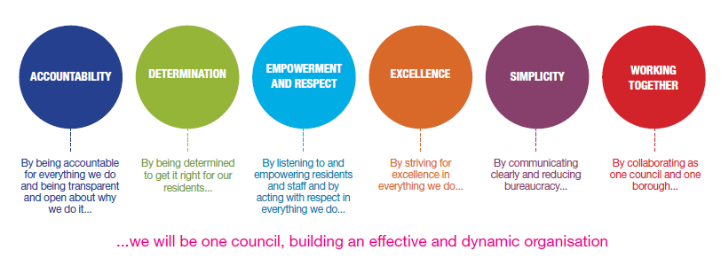
Job Description

Job Title: | Administration Officer
Grade and Salary: | Grade 4: £26427 to £26847
Reports to: | Administration Manager
Post Number: | AC3

Role Purpose:
To carry out office procedures within Bereavement Services in a smooth, efficient and sensitive manner. This involves undertaking administration duties relating to burial, cremation and memorial sales.

Specific Responsibilities:

- – Duties specific to the post

1.1 – Dealing sensitively and efficiently with queries and complaints from mourners, funeral directors, clergy, stonemasons, contractors, other staff and the public.

1.2 – To book in burials and cremations and maintain the cemetery and crematorium records e.g. forms, certificates etc.

1.3 –Completing daily work for cremations, including chapel, organists and minister instructions and marking back cards in the cremation records.

1.4 – Taking minutes at meetings, typing of letters, forms and filing.

1.5 – Dealing with daily incoming and outgoing post and issuing receipts for memorials.

1.6 –Input and retrieval of computer data.

1.7 – To maintain memorial records, e.g. wall plaques, book of remembrance, memorial cards and cemetery memorials etc.

1.8 – To advise the bereaved on their memorial options and process their application forms.

1.9 – To receive, record, balance and bank income.

1.10 – To process Memorial Applications in accordance with NAMM requirements

1.11 – To carry out genealogy searches as required.

1.12 – To assist with basic chapel duties in the event of staff shortage.

1.13 – To undertake any other duties as considered appropriate to the post that may be assigned by the Principal Bereavement Services Officer or Administration Manager.

1.14 – On the request of the Principal Bereavement Services Officer or Administration Manager, to be prepared to carry out duties at either Gornal Wood or Stourbridge Offices.

Key Responsibilities:

- To be accountable for and promote equality, diversity and community cohesion to meet Group, Department and Function objectives. All employees have a responsibility not only for their own behaviour, but also for others regarding equality of opportunity. Any incident must be reported.

- To participate in a Performance Review and Development meeting and undertake a plan of training where necessary. Develop his/her own skills and expertise in a professional manner.

- In addition to all the responsibilities listed above, all employees must be flexible in their approach and undertake other duties that are commensurate with post holder’s level, wherever they may be, to achieve the objectives of the Group.

- To represent the Council and Group in a professional manner meeting the Corporate and Group aims. To comply with Group and Corporate policies.

- If appropriate to be responsible for the recruitment and performance management of designated teams and individuals in accordance with Corporate and Group aims and management style.

- To comply with the council’s financial regulation and standing orders

- To actively promote Dudley’s commitment to safeguarding and promoting the welfare of children, young people and vulnerable adults at a level appropriate to this group.

- Employees must comply with health and safety legislation and will be required to comply with the Council’s Health and Safety Policies. All employees must ensure that they take reasonable care of their own health and safety as well as the health and safety of any person that is affected by their actions.

- To be responsible for adhering to legislative requirements and Council Policies and Procedures including, but not exclusively health & safety, Data Protection and Internet/Email use.

Special Conditions:

Driving Licence will be subject to checking with the DVLA.

Prepared by: | Ian Bailey
Date: | 21 September 2026

Essential criteria:
Person Specification
Qualifications and Experience |  | Application form | Technical assessment | Interview
 | Experience of working in an office environment | √ |  | √
 | Experience of dealing with the public on a regular basis both face to face and on the telephone | √ |  | √
 | Experience of working in a sensitive or caring environment | √ |  | √
 | 4 G.C.S.E grades A to C (or equivalent) one of which must be in English) | √
Skills and abilities
 | Able to use a computer to produce letters, reports and spreadsheets | √ |  | √
 | Able to manage and prioritise own workload |  |  | √
 | Able to communicate clearly and effectively both verbally and in writing | √ |  | √
 | A knowledge of Equality & Diversity issues | √ |  | √
 | Able to deal with members of the public in a sensitive and polite manner |  |  | √
 | Able to work effectively as part of a small team | √ |  | √
 | Ability to respond to difficult situations in a calm and professional manner |  |  | √
 | Prepared to work at Gornal or Stourbridge office as required |  |  | √
 | Self motivated and able to work unsupervised |  |  | √
 | Ability to work under pressure | √ |  | √

