Panel Coordinator

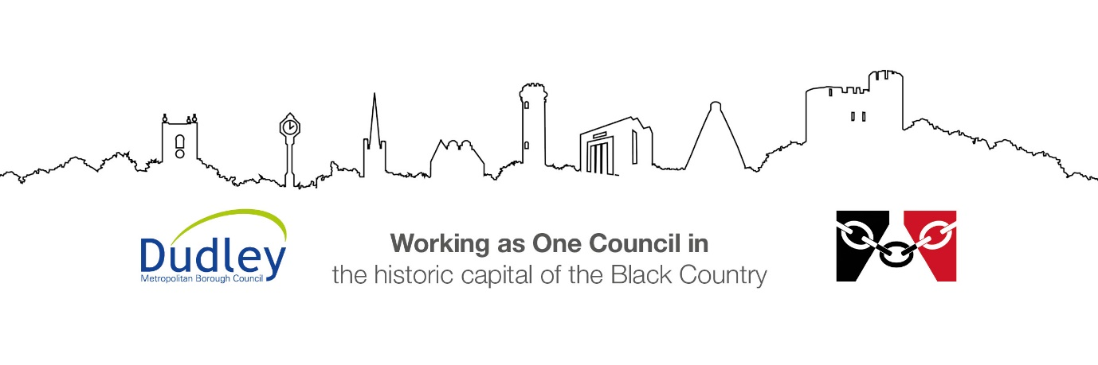

DMBC Operating Model 2024 - Vision:

A community-focused, financially resilient, collaborative, and sustainable council delivering the services required to support and meet the essential needs of residents, businesses, and the local economy.
Case for Change July 2024

Our Values:
Our values describe what we stand for and how we operate, and we expect our values to be lived and role-modelled throughout our organisation.

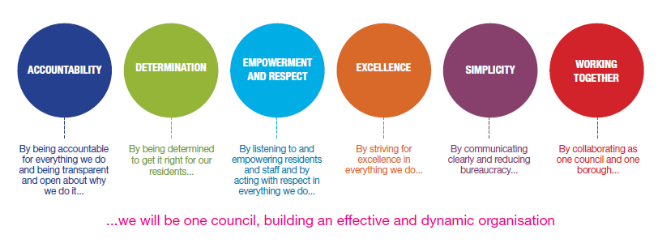
Job Description

Job Title: | Panel Coordinator
Grade/Salary: | 4
Reports to: | AD – Quality and Improvement
Post Number: | AC3

Role Purpose:
To lead, coordinate, and quality-assure the operational delivery of a weekly multi-agency panel within Children’s Services. The postholder will ensure the panel runs to a high standard, with robust process control, clear timelines, accurate documentation, and proactive oversight of workflow.
This role will strengthen consistency, ownership, reliability and drive standards across panel administration and stakeholder engagement.

Specific Responsibilities:

- Own the end-to-end coordination of a weekly decision-making panel
- Implement and manage a clear timetable for report requests, submissions, pack preparation and circulation
- Ensure agendas and panel packs are accurate, complete, quality-checked, and circulated within agreed timeframes.
- Produce and/or quality assure minutes with clear actions, owners and deadlines
- Maintain and quality check panel trackers, ensuring records are accurate, and up to date.
- Proactively identify missing or inconsistent information, checking relevant systems and liaising with social work teams to resolve gaps prior to panel.
- Drive improved task ownership and reduce repeat follow-up
- Standardise templates, filing and workflow processes.
- Act as a central point of contact for panel members, social work teams, and senior leaders, ensuring clarity of expectations and communication.
- Identify process improvements and implement practical changes to enhance efficiency and reliability
Key Responsibilities:

- To be accountable for and promote equality, diversity and community cohesion to meet Group, Department and Function objectives. All employees have a responsibility not only for their own behaviour, but also for others regarding equality of opportunity. Any incident must be reported.

- To participate in a Performance Review and Development meeting and undertake a plan of training where necessary. Develop his/her own skills and expertise in a professional manner.

- In addition to all the responsibilities listed above, all employees must be flexible in their approach and undertake other duties that are commensurate with post holder’s level, wherever they may be, to achieve the objectives of the Group.

- To represent the Council and Group in a professional manner meeting the Corporate and Group aims. To comply with Group and Corporate policies.

- If appropriate to be responsible for the recruitment and performance management of designated teams and individuals in accordance with Corporate and Group aims and management style.

- To comply with the council’s financial regulation and standing orders

- To actively promote Dudley’s commitment to safeguarding and promoting the welfare of children, young people and vulnerable adults at a level appropriate to this group.

- Employees must comply with health and safety legislation and will be required to comply with the Council’s Health and Safety Policies. All employees must ensure that they take reasonable care of their own health and safety as well as the health and safety of any person that is affected by their actions.

- To be responsible for adhering to legislative requirements and Council Policies and Procedures including, but not exclusively health & safety, Data Protection and Internet/Email use.

Special Conditions:

This post is subject to the DBS checking process

Driving Licence will be subject to checking with the DVLA. It is a council requirement to have Business Use Car Insurance and a valid MOT certificate (For cars over 3 years old) (delete if not applicable)

The post holder is required to work onsite 3 days per week

Prepared by: | Matt Smith
Date: | 17th August 2026

Essential criteria:
Person Specification
Qualifications and Experience |  | Application form | Technical assessment | Interview
 | Experience coordinating statutory or governance panels within Children’s Services or a similar regulated environment | X |  | X
 | Demonstrable experience improving administrative processes and raising performance standards | X | X | X
 | NVQ level 3 or equivalent qualification in administration | X
 | Commitment and willingness to undertake further training and development, dependant upon existing qualifications and requirement so the post | X |  | X
Skills and abilities
 | Proven commitment to public service and the ability to champion equality, diversity and inclusion and embedding these as core values | X |  | X
 | Able to implement structure, timetables and escalation routes | X | X
 | Confident working with social work teams and senior leaders | X |  | X
 | Being able to demonstrate knowledge and use a wide range of ICT systems | X | X

