Family Time Worker



DMBC Operating Model 2024 - Vision:

A community-focused, financially resilient, collaborative, and sustainable council delivering the services required to support and meet the essential needs of residents, businesses, and the local economy.
Case for Change July 2024

Our Values:
Our values describe what we stand for and how we operate, and we expect our values to be lived and role-modelled throughout our organisation.

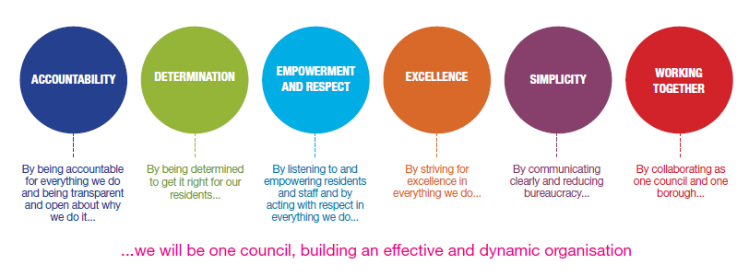
Job Description

Job Title: | Family Time Worker
Grade/Salary: | 6
Reports to: | Senior Lead
Post Number: | Click or tap here to enter text.

Role Purpose:

- To provide supervised family time to families who need this service. This will include providing advice, support and guidance to families who need help with developing parenting skills.
- To work closely with social workers and other professionals who are undertaking assessments and implementing care plans and support packages for children, young people and their families where appropriate.
- The post requires the post holder to work flexibly and to undertake some work outside of the normal office hours and / or at weekends

Specific Responsibilities:

- Undertake family time sessions working with children from newborn to 18years of age
- Directly supervise children and families during their allocated family time
- Take accurate and detailed recordings of observations between children and their families
- Supervise sessions between 1 hour and 3 hours in length
- To safeguard children and families and report any concerns to the allocated social worker
- To manage your own caseload of families and offer consistency to children and young people
- Adhere to departmental policy and procedures
- Lone work with families, undertaking family time sessions in the hubs, community and family home - these are often activity based for up to 3 hours.
- Some sessions can be up to 3 hrs in length which can be sedentary in nature taking place within the family hub or home
- Some sessions can be up to 3 hrs in length within the community and can be physical in nature.
- Assisting children into and out of car seats, this includes some manual handling and lifting –
- Liaise directly and work with a range of other professional agencies and partners
- Develop positive working relationships with children and families
- Support children and parents practically and emotionally to make family time sessions as positive as possible
- To assess the quality of parenting observed during the family time session and use this evidence to complete reports as required, some of which may be required by the court
- To recognise and manage any risk of harm and intervene appropriately to deescalate the risk and/ or bring in additional support as required.
- To produce records of your work, adhere to confidentiality, information sharing protocols and risk assessment processes.
- To participate in supervision, training and appraisal
- To keep records of your work, adhere to confidentiality, information sharing protocols and risk assessment processes.
- To comply with Dudley MBC’s Health and Safety Policy, Data Protection Policy and to protect the health, safety and welfare of yourself and others.
- To work flexibly as may be required by the needs of the service and carry out any other reasonable duties as required.
- Full driving license, vehicle business insurance and access to a road worthy vehicle to legislative requirements for work purposes.

Key Responsibilities:

- Proven commitment to public service and the ability to champion equality, diversity and inclusion and embedding these as core values All employees have a responsibility not only for their own behaviour, but also for others regarding equality of opportunity. Any incident must be reported.
- To participate in performance review and development meetings and undertake a plan of training where necessary. Develop his/her own skills and expertise in a professional manner.
- In addition to all the responsibilities listed above, all employees must be flexible in their approach and undertake other duties that are commensurate with post holder’s level, wherever they may be, to achieve the objectives of the service.
- To represent the Council and Service in a professional manner meeting the Corporate and Service aims and objectives. To comply with the Service and Corporate policies and procedures.
- To comply with the council’s financial regulation, policies and procedures.
- To actively promote Dudley’s commitment to safeguarding and promoting the welfare of children, young people and vulnerable adults at a level appropriate to this group.

- Employees must comply with health and safety legislation and will be required to comply with the Council’s health and safety policies. All employees must ensure that they take reasonable care of their own health and safety as well as the health and safety of any person that is affected by their actions.
- To be responsible for adhering to legislative requirements and Council Policies and Procedures including, but not exclusively Health & Safety, Data Protection and Internet/Email use.

Special Conditions:

This post is subject to the DBS checking process.

Driving Licence will be subject to checking with the DVLA. It is a council requirement to have Business Use Car Insurance and a valid MOT certificate (For cars over 3 years old)

The post holder is required to work onsite

Prepared by: | Ms Maxine Brown
Date: | 20th July 2026

Essential criteria:
Person Specification
Qualifications and Experience |  | Application form | Technical assessment | Interview
 | NVQ 3 in working with children and families or equivalent | √
 | Demonstrate a wide variety of experience of working with young people, their families or a staff team. | √ |  | √
 | Experience of Developing, Implementing and reviewing new processes and work practices.??? |  |  | √
 | Knowledge and experience of recognising and protecting children from abuse and participating in the evaluation of the risk of abuse to self or others. |  |  | √
 | Knowledge of LCS, Word, Excel, Outlook or other computer systems | √
Skills and abilities
 | Proven commitment to public service and the ability to champion equality, diversity and inclusion and embedding these as core values
 | An ability to effectively engage, sustain relationships and disengage with young people and their families in a positive way |  |  | √
 | An ability to develop effective working relationships between workers, the local community and other agencies. |  |  | √
 | Ability to communicate effectively both orally and in writing | √ | √ | √
 | Ability to produce a variety of information including case notes and/or reports to aid decision making relating to supervised family time. Records may be used during court proceedings or other relevant assessments. |  | √
 | Knowledge of legislation, policy and practice in relation to working with children and families. | √ |  | √
 | Knowledge of child development and the needs of children |  |  | √
 | Demonstrate a commitment to participate in training and developing ones own knowledge and practice |  |  | √

