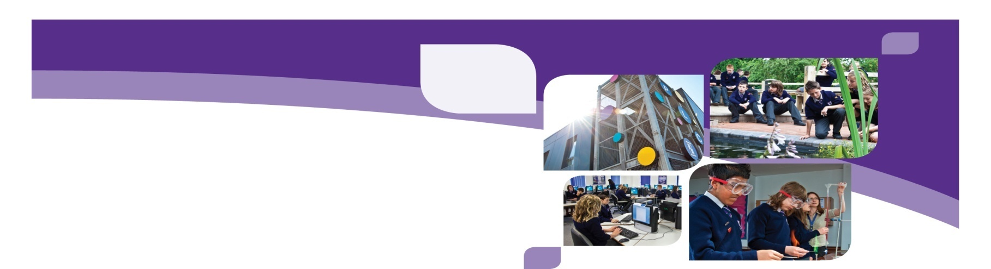**Dormston School**

Mill Bank, Sedgley, Dudley, DY3 1SN

**Person Specification - Learning Support Assistant**

|  |  |
| --- | --- |
| EXPERIENCE | * experience of working within a school setting (secondary preferred) or with 11-16 year olds in other capacities. * experience of working with children challenged by the school environment; |
| QUALIFICATIONS | * level 2 qualifications or above; * grade C GCSE in Maths & English preferred; |
| PRACTICAL SKILLS | * ability to work with both adults and children; * ability to support physically impaired 11 – 16 year olds. |
| PERSONAL QUALITIES | * a commitment to challenging students to reach the highest possible standard; * good communication skills; * an effective team member; * suitability to be working with children and young people; * enthusiasm for personal development; * Dormston School is committed to safeguarding and promoting the welfare of children and young people and expects all staff and volunteers to share this commitment. Please note that this post is subject to Enhanced DBS Clearance, Qualification and ID Checks. |