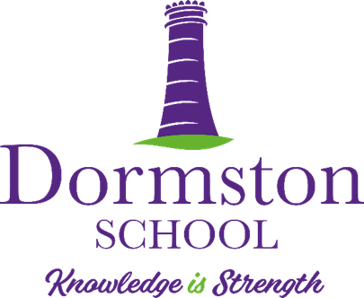

**APPLICATION GUIDANCE NOTES**

Thank you for your interest in our vacancy. Please read this guidance carefully before applying for the position. Please remember, the more accurately your Application Form is completed the better. First impressions really do count! **Please note that due to the large number of applications we receive we will usually only contact those who have been successfully shortlisted. This is usually within 5 days of the closing date.**

* **Covering Letter**

We would request that all teaching vacancy candidates submit a covering letter with their application of no more than 2 x A4 pages.

* **Chronological Employment History**

You will be asked on the Application Form to complete a **‘full chronological employment history’**. This starts from the time you left school to your most recent employment. We will require **month year from – month/year to for each employment***.* Any gaps in employment; i.e. unemployed, raising a family, travelling, college **must** also be declared in this section*.* A Chronological Employment History check will be made on ALL short-listed candidates.

* **References**

In line with our Safer-Recruitment procedures, References are taken on ALL short-listed candidates, prior to interview, unless you have refused permission. If you have refused permission we will speak to you about this. When putting your References details down if you don’t know their email address consider finding it out. It really helps us to process your reference request quickly and efficiently. It is always worth giving any references a courtesy call to let them know you are using them as a reference first. We will always require a reference from your current or most recent employer. **If you have worked with children previously a reference from this organisation will also be required.**

* **Being called for Interview**

You will normally be called for interview within 5 days of the closing date. As part of our Safer Recruitment process ID & Qualification Checks will need to take place on arrival at the interview. It is important that you bring all necessary ID/Qualifications with you at your interview. We need at least 1 form of photographic ID if possible if not a birth certificate.

You will need to bring along to the interview any ‘original’ qualification certificates you have declared on your Application Form.  **Please bring these along in one envelope preferably so they can be quickly and easily photocopied**. If you do not have original copies of your certificates replacement certificates may need to be sourced as part of any job offer made.

**Safeguarding Statement**

**Dormston School is committed to ensuring the safeguarding of all its pupils. ALL posts are subject to Enhanced DBS Clarence and ID/Qualification checks.**