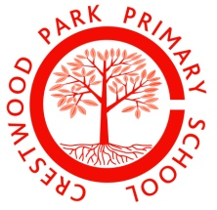

Crestwood Park Primary School

Class Teacher

## Person Specification

# Qualifications and Training

Essential – Qualified Teacher Status

# Experience

Essential - Proven and demonstrable experience in both Key Stages

Experience of ongoing assessment procedures

# Knowledge and Skills

Essential - Excellent classroom practice

Knowledge of effective teaching and learning strategies

Knowledge of curriculum development

Ability to accurately assess and record pupil progress

# Personal Skills

Essential - Commitment to a team approach of working

Proven commitment to school though contact prior to application

Evidence of reflective practice

Commitment to support and facilitate the school’s vision for continued

improvement

Good communication skills

Ability to create good working relationships with pupils, staff, governors and parents

A commitment to pursue further professional development