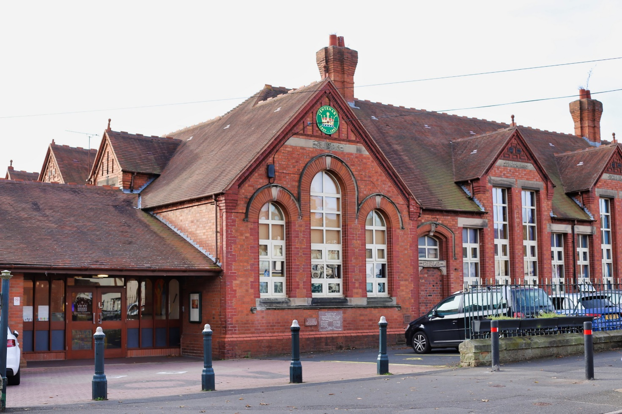

**SUPERVISORY ASSISTANT**

**AT QUEEN VICTORIA**

**PRIMARY SCHOOL, SEDGLEY**

**RECRUITMENT pack**

**CANDIDATE INFORMATION PACK**

**Supervisory Assistant**

**Fixed Term until 31st August 2025 with the potential for longer**

**Salary £20,208.43 pro-rata to £5,461.00pa**

**Grade 2 SCP3 £12.45 per hour**

**Required as soon as possible**

**10 hours per week, Term Time Only**

Queen Victoria Primary School is a caring school, serving children and families in the heart of Sedgley. We believe every child is worthy and capable of success and happiness, and this shows in every interaction.

We are seeking to appoint a Supervisory Assistant who is committed, highly motivated, reliable and hard-working to join a friendly and established team to deliver a high-quality service. Previous experience would be advantageous.

**Work Pattern**

Monday – Friday 11.30am – 1.30pm daily

Visits to the school are warmly welcomed and can be arranged by contacting the school office on 01384 812553.

Queen Victoria Primary School is committed to safeguarding and promoting the welfare of children and expects all staff and volunteers to share to share this commitment. We will carry out pre-appointment checks including DBS and will disqualify any applicant where we consider the outcomes to be unsatisfactory. This post is exempt from the Rehabilitation of Offenders Act (ROA) 1974.

We are equally committed to ensuring that no applicant will be disadvantaged or discriminated against because of their protected characteristics under the Equality Act 2010.

This role has been assessed as working in regulated activity and is subject to an Enhanced DBS plus Children’s Barred List Check.

It is an offence to apply for this role if you are barred from engaging in regulated activity relevant to children.

Online searches will be carried out on shortlisted candidates.

As a Trust we are committed to ensuring that throughout our recruitment process, no applicant will be disadvantaged or discriminated against because of the protected characteristics under the Equality Act 2010.

**Closing date for applications – 17th January 2025**

Only successful candidates will be contacted.

**Interview date -** to be confirmed.

**ABOUT QUEEN VICTORIA PRIMARY**

**Message from the Head Teacher**

Queen Victoria Primary School is an exceptionally caring school, which has been serving children and families in the heart of Sedgley since 1896. We believe every child is worthy and capable of success and happiness and this shows in every interaction. Our staff create the conditions for children to grow into individuals who care about themselves, each other, and the world they live in. Our children, from Nursery to Year Six, are at the heart of everything we do every day, in every decision and every action. Our staff will move heaven and earth to ensure children get what they need to succeed. We are full of hope and ambition for our children. We believe one of our key purposes is to help our children develop into respectful and responsible citizens who make positive contributions to life in Sedgley and beyond. As a school, we strive for excellence: relentless in our pursuit of providing excellence, balancing academic achievement and personal development.

You will be joining a dedicated and motivated team of staff who are incredibly friendly and supportive. We are committed to developing staff and offer quality professional development opportunities and encourage reflective practice. At Queen Victoria Primary School, we prioritise the wellbeing of all children and staff, continually reflecting upon workload whilst striving to provide the highest quality education and experience for our children.

**ABOUT STOUR VALE ACADEMY TRUST**

Our multi-academy trust was founded in 2017 and developed from collaboration between schools, the significant positive impact of which convinced three schools, two secondary and one primary, that together we would have much greater capacity to continuously improve. Over time, Stour Vale has steadily grown. We began as a cross-phase multi-academy trust and as we have grown, both secondary and primary schools have joined us. There are currently twelve member schools, six primary, one junior, on infant with day nursery and four secondary.

As a successful family of schools, delivering high-quality education for the communities we serve, Stour Vale values its diversity. Each school brings their own distinct character, community, history and identity. We celebrate the uniqueness of member schools, recognising that there is a great deal to learn from education in different contexts. This is also the reason why we remain outward-looking, committed to learning from research and excellent practice across the education system.

**OUR VISION AND VALUES**

Stour Vale Academy Trust holds children and young people at the heart of all that we do. We recognise that as a multi-academy trust we exist in order to advance education for the public good. Our mission, therefore, is to improve life opportunities for children and young people by both providing the best possible education and care to pupils in Stour Vale member schools and by having a positive impact across the wider education system. Our values are encapsulated in four words:

We describe our shared approach to school improvement as ‘secure autonomy’. Headteachers, with school leadership teams and staff, have autonomy to lead school improvement in their own schools, responsively and in collaboration with others within and beyond our trust. We believe that this approach enables us to grow, attract and retain excellent school leaders and to develop the most innovative and impactful school improvement strategies. We recognise that this autonomy must be secured within the structure of the multi-academy trust, and our model of challenge and support for impact, underpinned by our shared values, ensures sustained school improvement and a sharp focus on outcomes for pupils. This in turn realises our ambition that ***Stour Vale*** member schools will ***create the difference together.***

**JOB DESCRIPTION**

**SUPERVISORY ASSISTANT**

**Main Job Activities**

The duties of a Supervisory Assistant involve the safe supervision of pupils during the lunch period and would normally include the following:-

1. Ensuring the safety and wellbeing of children during the lunchtime break.
2. Supervising and encouraging washing of hands prior to entering the Dining Hall.
3. Management and supervision of children queuing for lunch.
4. Supervising pupils when eating meals and assisting pupils with opening packets etc particularly younger children or children with SEND.
5. Ensuring crockery, cutlery, trays, leftovers and refuse are returned by the pupils to the relevant collection and disposal points.
6. Organise and promote play activities in the playground, and indoors in inclement weather.
7. Dealing with any accidents, spillages [including all body fluids types] ensuring that these do not cause a safety hazard to pupils or other staff.
8. Managing behaviour of pupils, in line with school policy, in the playground and indoors when the weather is inclement.
9. Reporting serious misdemeanours to a member of SLT.
10. Ensuring children remain outside during lunch time unless directed otherwise.
11. Interact with children monitoring any groups of children that require redirection or support fully engage in their play.
12. Report serious misdemeanours to the Midday Superintendent in line with school policies.
13. Undertaking any appropriate training commensurate with the post of supervisory assistant.
14. Any other related duty, as directed by your Supervisor.

Name: ……………………………………………………….

Signed: ……………………………………………………….

Date: ……………………………………………………….

**PERSON SPECIFICATION**

**SUPERVISORY ASSISTANT**

|  |  |  |
| --- | --- | --- |
| **Categories** | **Essential** | **Desirable** |
| **QUALIFICATION** |  |  |
| Good standard of literacy and numeracy. | ◆ |  |
| Willing to undergo appropriate additional training. | ◆ |  |
| First Aid Qualification. |  | ◆ |
| **EXPERIENCE** |  |  |
| Practical supervisory experience with children. | ◆ |  |
| Experience of pupils with learning difficulties and challenging behavior. |  | ◆ |
| **DISPOSITION** |  |  |
| Tolerant. | ◆ |  |
| Able to work unsupervised. | ◆ |  |
| Discreet. | ◆ |  |
| Ability to promote positive behaviour. | ◆ |  |
| Able to act on own initiative. |  | ◆ |
| **PRACTICAL SKILLS** |  |  |
| Understanding the importance of keeping children safe. | ◆ |  |
| Able to initiate games. | ◆ |  |
| Able to deal with emergencies calmly. | ◆ |  |
| Able to communicate effectively with pupils and staff including being sensitive to the needs of SEND pupils. | ◆ |  |
| Able to manage other adults. | ◆ |  |
| Organisational skills with children working indoors in inclement weather. | ◆ |  |
| **OTHER FACTORS** |  |  |
| Able to maintain confidentiality. | ◆ |  |
| Ability to remain calm under pressure. | ◆ |  |
| Motivated and able to work on own initiative. | ◆ |  |
| Be aware of and apply the school’s health and safety practices and procedures. | ◆ |  |
| Willingness to participate in the wider life of the school. |  | ◆ |

Name: ……………………………………………………….

Signed: ……………………………………………………….

Date: ……………………………………………………….

